ABUNDANCE OF LIGHT CORD CUTTING
PRAYER MACRO’S BY ERIKA L SOUL

Here is a collection of my Macro Prayers I have been creating over a long period of time. I am making this collection to keep them all in one place and to share the full wording to my own Macro’s . If you are after the full wording of Macro’s that I haven’t personally created that are on the Common List in the file I have available on my cord cutting web page, please look for them in Alyssa Mary Rose’s books that are free on my webpage. In the Common List Macro Prayers Word file document I have put an * asterix at the end of the details of each Macro there is wording for, please note there are only a handful of Macro’s on the Common List with the wording available.

Please NOTE all of these whole Macro Prayers have been written and created by myself Erika L Soul and thus belong to me, so these Macro’s in this file are for your personal use only and sharing to another person privately to help them is fine. Any sharing of these Macro Prayers publically online is only if you have contacted me and I have given my persmission first, thankyou for respecting my healing work.

I practice The Abundance of Light Cordcutting Healing Technique created by Alyssa Mary Rose. For all of her FREE resources that are now available again online you can visit my website page www.rainbowhealings.com/cord-cutting

If you have any questions on how to cut cords with these Prayer Macro’s or want to learn how to practice Energy Cord Cutting or you would love a Cutting Cords session with me please contact me via my website or email soulerika@rainbowhealings.com

Erika L Soul
Intuitive Healing Arts Practitioner.
Melbourne Australia
www.rainbowhealings.com

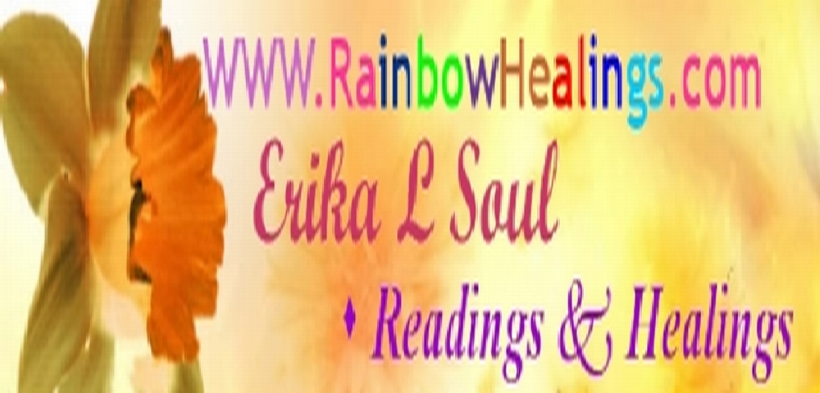

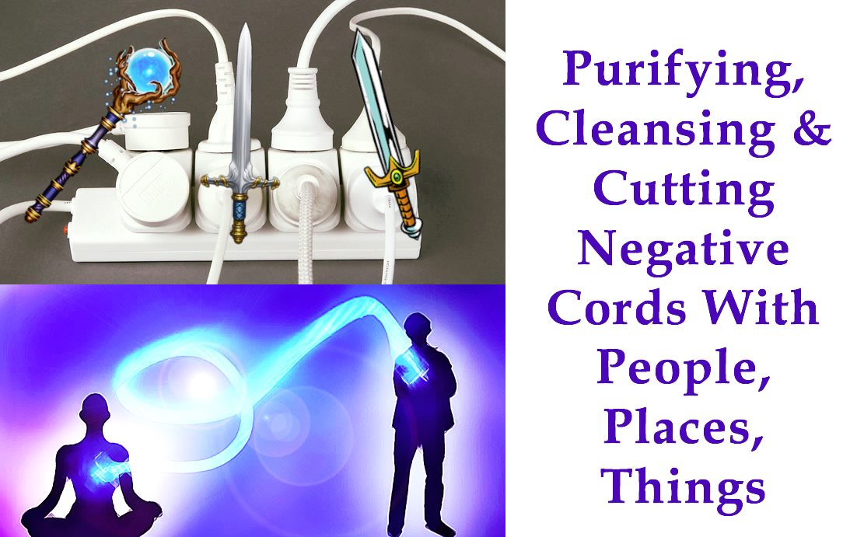
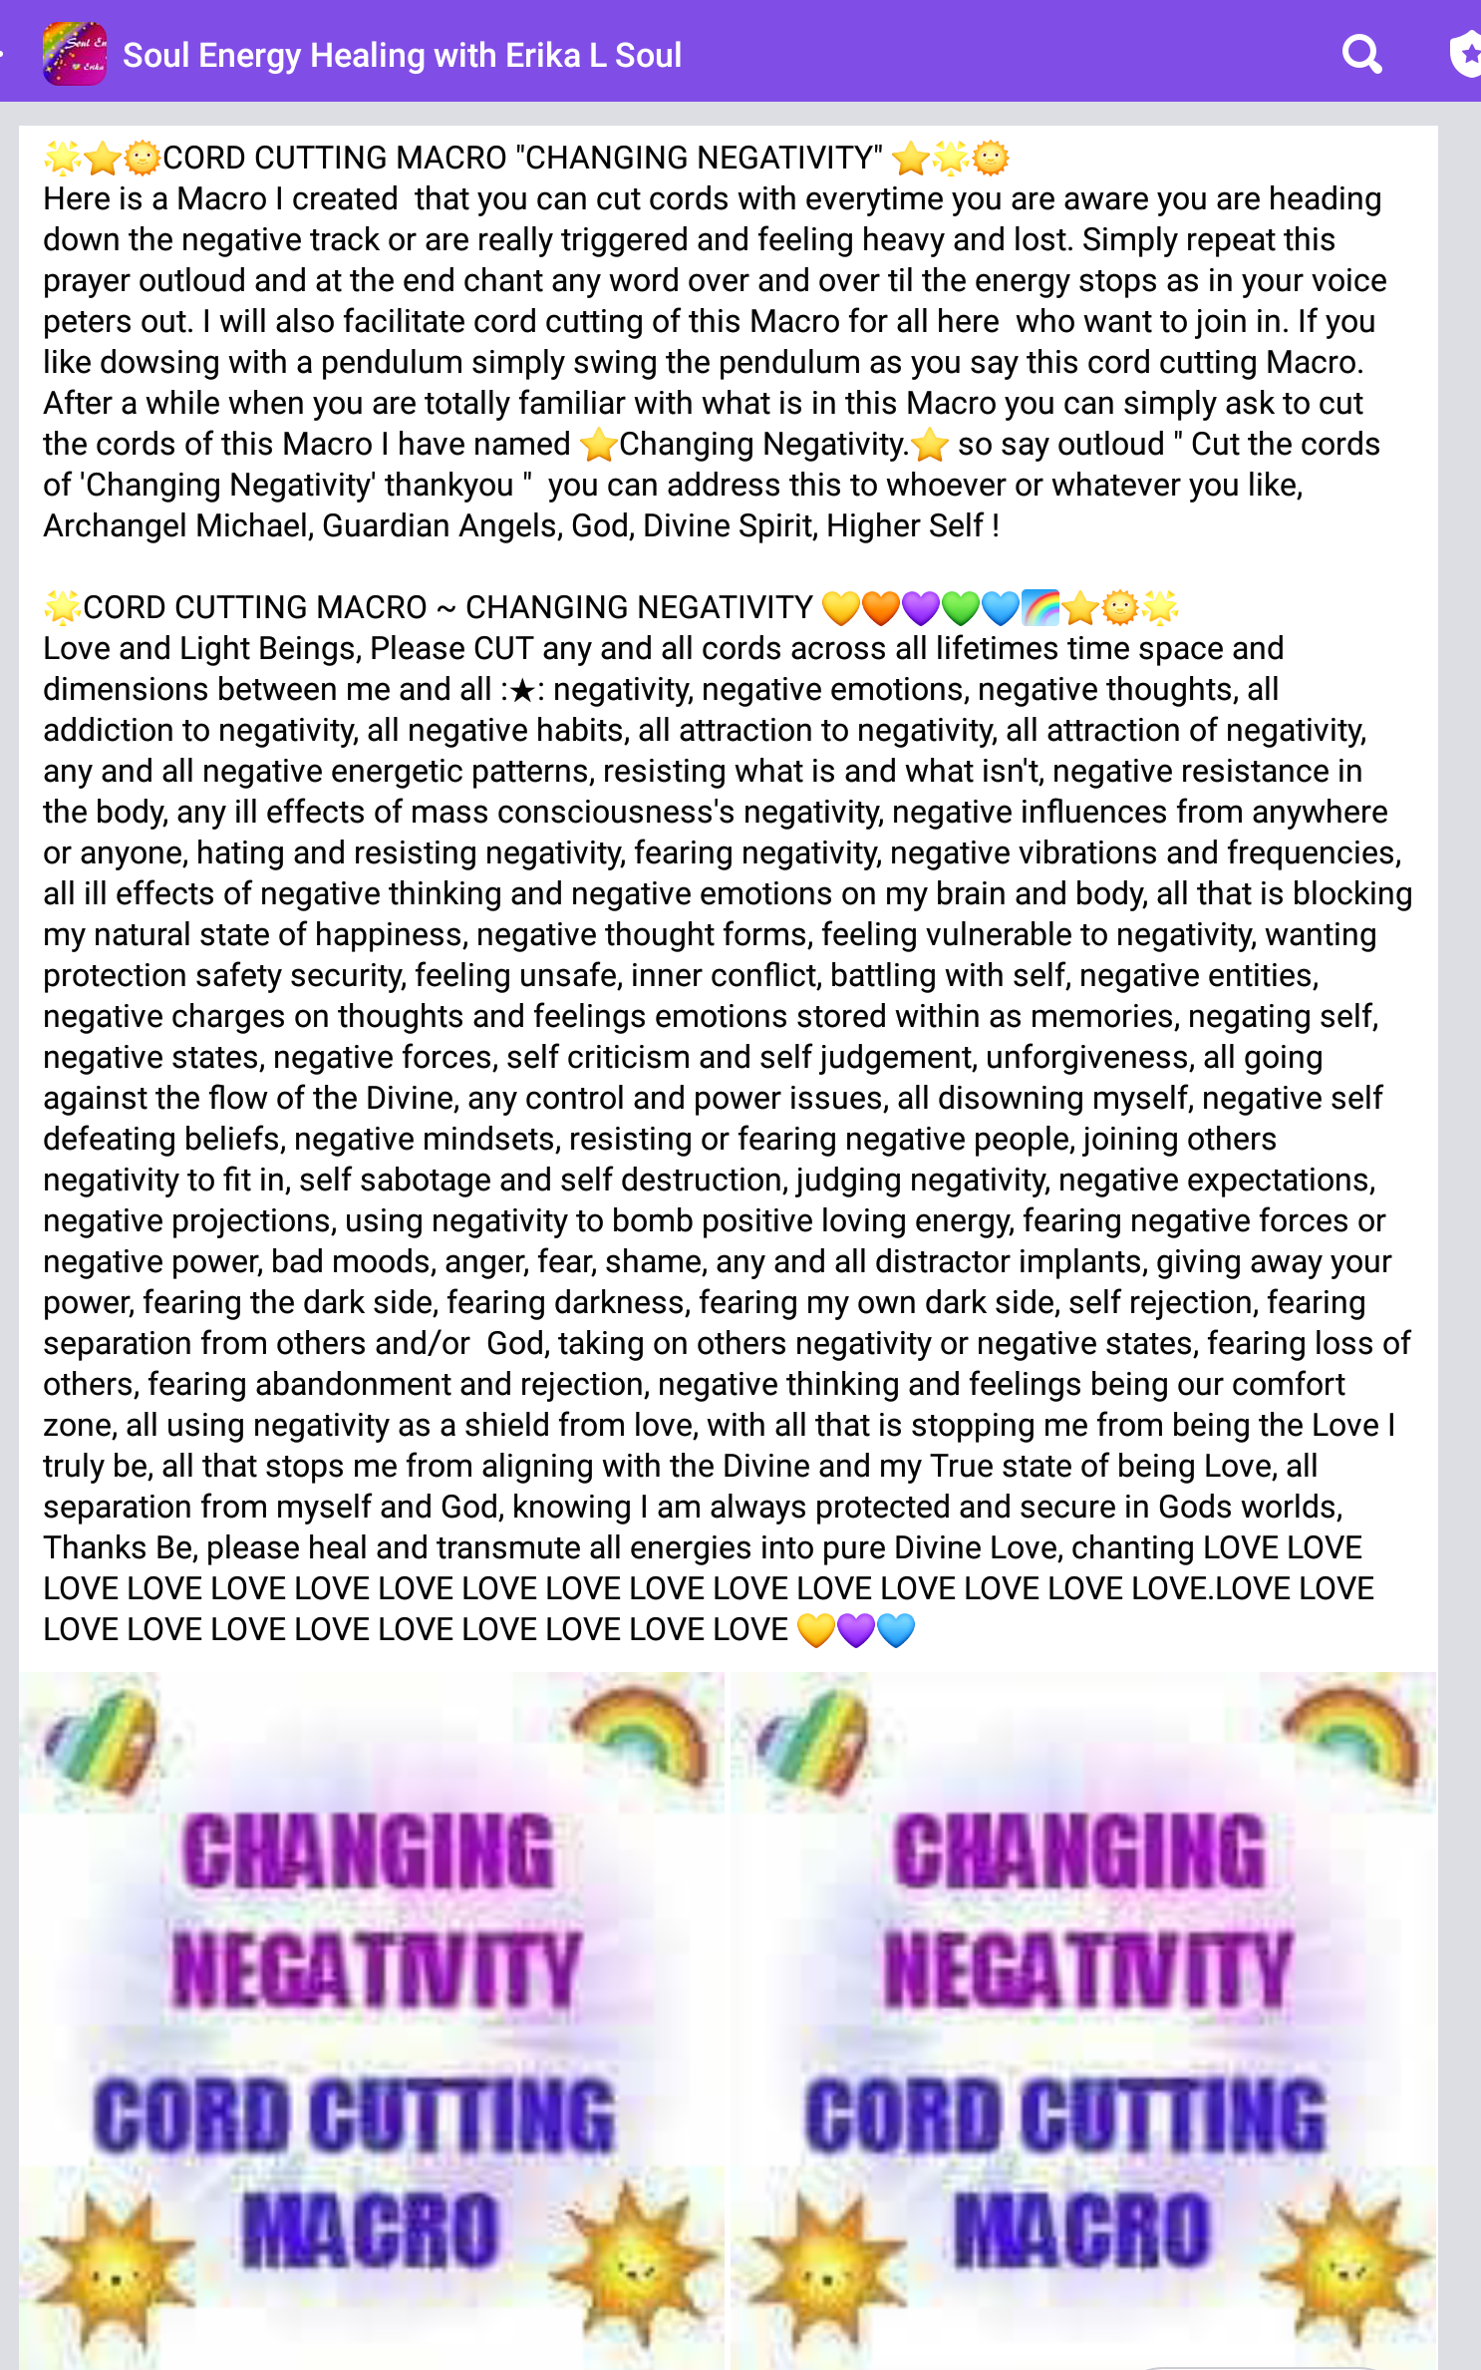

74★CORD CUTTING MACRO ~CHANGING NEGATIVITY★
Love and Light Beings, Please CUT any and all cords across all lifetimes time space and dimensions of : negativity, negative emotions, negative thoughts, all addiction to negativity, all negative habits, all attraction to negativity, all attraction of negativity, any negative energetic patterns, resisting what is and what isn't, negative resistance in the body, any ill effects of mass consciousness's negativity, negative influences from anywhere or anyone, hating and resisting negativity, fearing negativity, negative vibrations and frequencies, all ill effects of negative thinking and negative emotions on my brain and body, all that is blocking my natural state of happiness, negative thought forms, feeling vulnerable to negativity, wanting protection safety security, feeling unsafe, inner conflict, battling with self, negative entities, negative charges on thoughts and feelings emotions stored within as memories, negating self, negative states, negative forces, self criticism and self judgement, unforgiveness, all going against the flow of the Divine, any control and power issues, all disowning myself, negative self defeating beliefs, negative mindsets, resisting or fearing negative people, joining others negativity to fit in, self sabotage and self destruction, judging negativity, negative expectations, negative projections, using negativity to bomb positive loving energy, fearing negative forces or negative power, bad moods, anger, fear, shame, any and all distractor implants, giving away your power, fearing the dark side, fearing darkness, fearing my own dark side, self rejection, fearing separation from others and/or God, taking on others negativity or negative states, fearing loss of others, fearing abandonment and rejection, negative thinking and feelings being our comfort zone, all using negativity as a shield from love, with all that is stopping me from being the Love I truly be, all that stops me from aligning with the Divine and my True state of being Love, all separation from myself and God, knowing I am always protected and secure in Gods worlds,Thanks Be, please heal and transmute all energies into pure Divine Love, chanting LOVE LOVE LOVE LOVE LOVE LOVE LOVE LOVE LOVE LOVE LOVE LOVE LOVE LOVE LOVE LOVE.

-----------------------------------------------------------------------------------------------------------------------------

83.CHRISTMAS CORD CUTTING PRAYER MACRO - Erika L Soul
Love and Light Beings, please include all appropriate beneficial Macro’s and aid and heal all affected by this Macro. Please cut any and all cords of attachments/ negativities any cords not of the highest good across lifetimes time and space between myself and Christmas, all past Christmases, all negative expectations of Christmas, all memories, all family gatherings, all that stuff with Christmas, commercialism of Christmas, having enough money for Christmas, overspending on Christmas, what to buy people, all conflict, all the mass social consciousness of Christmas, All limitations and restrictions with Christmas, all fear, anger, all issues of having enough doing enough giving enough, all lack beliefs, childhood memories of Christmas, having enough time for everything, all with food and eating, drinking, over indulging, too little time, busyness, overdoing things, overworking, stress, pressure, family conflicts, shopping, all stress with Christmas, Christmas Day and all your plans, what you want to do for Christmas, who to be with, having family to be with, spending time with people you enjoy, alone at Christmas, being loved, being in appreciation and gratitude, receiving gifts, being able to feel the love joy and happiness at Christmas, not feeling the love and gratitude, relaxation, expectations of others of you at Christmas, wanting the best Christmas, not having the Best Christmas, fear of failure, fear of other people at Christmas time, hating Christmas, decorations, feeling Christmassy or lacking the Spirit of Christmas, end of the year, holidays, change, New Year, whatever is preventing you from having the kind of Christmas that is what you love and enjoy, having freedom to choose what you want to create for your own Christmas, giving to others, social gatherings, attending Christmas events and religious services, all you have about Christmas that is not love, only love is real and love is what I feel. In the Name of the Highest, Please change heal transmute all energies into pure Divine Love, chanting Love Love Love Love Love Love



81.* MOVE INTO YOUR GREATNESS*- MACRO PRAYER

We ask that together with the Cord Cutting Spiritual Beings Team we cut the Cords of all Anger, judgement, blame, shame, guilt, regret, negativity, opinions, hate, we have received from others and we have of others, that we have towards ourselves, all self hate, unforgiveness, intolerance, unworthiness, worthlessness, all trapped emotions of low self esteem and self abuse, all abuse mentalities, brainwashed mentalities, fear based judgements, negative energetic patterns, uncaringness, selfishness, ingratitude, resentment, resistance, separation from ourselves and others, separation from God, all that we use to feel less than others, all making ourselves small and not worthy of good, all ego based perceptions, all that says we can't be do or have something because we are not good enough or capable of doing having being our real divine selves. all blocks to self love. Thankyou Angels, Divine Spirit of our Higher Self, Spiritual Beings, for transposing all of these energies, beliefs patterns, emotions into Higher Energies that Bless us with Divine Love, Divine Truth, Divine Wisdom and Divine Goodness. Thankyou thankyou thankyou, God.

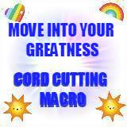

EVERYTHING IS PERFECT CORD CUTTING MACRO

HAS BEEN CREATED TO CUT CORDS WITH THE WORLDWIDE CORONAVIRUS SITUATION WITH ALL THAT IT’S BRINGING UP FOR EVERYONE, EVERYTHING CONNECTED TO IT HAS BEEN INCLUDED AS WELL AS MANY OTHER MACRO'S TO AID IN CLEARING THE CORDS AWAY THAT ARE BOTHERING YOU. IT HAS BEEN UPDATED QUITE A FEW TIMES WITH ALL ADDITIONAL ISSUES.
After you read the Macro and know what is in it and you have cut cords with it many times while reading it you can just say Cut the cords of the ‘Macro Everything is Perfect’ thankyou. So keep doing it any time you get affected. To cut the cords simply state outloud as you read it all and ask for it all to be cut for you as you read it or say it all silently .

I have created this Macro to aid in cutting cords with the Corona Virus 19 situation, and I have utilised Alyssa Mary Rose’s Abundance of Light Cordcutting technique which is what I use as an advanced cordcutting technique, having learnt and used this method since 2003. I have worked with many other types of cordcutting techniques however this one has been my main method for many years.

75. EVERYTHING IS PERFECT’ MEGA MACRO PRAYER by Erika L Soul

Love and Light Beings Please use all Macros to aid and heal all affected by this Macro also including the Macros ‘Just Clear the Lot God’, ‘Knowing My Power’, ‘Earth and Fire Work as One,’ Clean Up Prayer’, ‘Opening Up Gateways to New Experiences’, ‘Knowing my Power’, ‘Manifesting a Happy Present and Future’, “Wealth and Prosperity Prayer‘, Finding myself in a Peaceful Place’, “Remaining Strong and Grounded in Times of Intense Change, Freedom Prayer, My Privacy Prayer, Empowerment Prayer, Power over Prayer, Fear Illusion Prayer and all Macros and including all of the cords cut in the Barb Ball over the last year and this year re Corona Virus world wide pandemic stuff, please cut any and all cords of illusion, cords of attachment, cords not of the highest good, across the lifetimes, time and space, In the name of the Divine, between each individual and all of this Macro according to the highest order of needs upon their request of this Macro ‘Everything is Perfect’ please cut any and all cords of illusion, cords of attachment, cords not of the highest good, across the lifetimes, time and space, In the name of the Divine, between each individual and all of this Macro according to the highest order of needs upon their request of this Macro ‘Everything is Perfect’, Please cut any and all cords of fear, doubt, uncertainty, fear of the future, fear of disease, fear of lack, fear of control, fear of getting sick, fear of others, fear of germs, fear of viruses flu colds, fear of lack of power, fear of being controlled, fear of closeness, all that stuff with survival, fear of death, fear of pain and suffering, fear of starvation, fear of separation, fear of others, fear of contamination, with fear of lack of connection, fear of intimacy and connection, with all communion, with all media -news -information, with all mass hysteria, with all 24 distractor implants, with self empowerment, with self confidence, lack of self confidance, with all choices and freedom, with all negative emotions, unworthiness, uncleanliness, hygiene, scarcity, lust, scarcity consciousness, fear of deprivation, food, neediness, greed, panic, anxiety, doubt, faith and trust, limitations, isolation, wanting, lust, security, wanting security and not wanting security, wanting to separate cut off get away from, wanting closeness, having and not having, negativity, negative energies, negative entities, negative influences, negative power, lack of fun times, chaos, lack of sleep, rest, relaxation, having what you need when you need it, approval, disapproval, joy, lack of happiness, obsessing, others peoples stuff you take on board, mass consciousness, with all stress affecting our bodies immune system, with worry about our immune system, with all that stress, with all distress, with all affecting our brains function brain balance and brain health, fear of corona virus-19, with your whole relationship to the corona virus-19, with the identity of corona virus 19, with all the focus on this covid19 and giving it so much attention, with getting your mind off the covid19, with putting attention on what you desire to experience, with all fear of not enough, with aggression in others and self, all fear and ignorance, people doing foolish things, being stuck in fear about Covid-19, giving your power away, all hate, rage, shutting down, inner child insecurities, insecurity, fear of what will happen, money, income, work, negative
expectations, disconnecting from Love, with events being cancelled and not being able to attending social functions and get together with others, with all that is bothering me, all that stuff, all items on my list, all items on my black
list, all emotional stress, all physical stress, all mental stress, all spiritual stress, all financial stress, all work stress, all family stress, with all restrictions, with places being limited or shutdown, with not enough to do and too much time alone, being an observer,ceasing to hold opinions over the current situation with corona virus 19, with all disappointment in self and disappointment in others, judging others behaviour, stop the world I want to get off, with all addictions and needing things people money to be happy, disconnection from self, abandonment, self trust, trust in Life, mistrust, lies, illusions, misinformation, negative beliefs, all being controlled by fear, craziness, judging others and their choices, selfishness, judging gothers for their selfishness, self control, self discipline, Self Love, losing self, being lost, alone, frightened, overbuying, stocking up, hoarding, negative clouds blocking the sunshine of joy and happiness, wanting, getting, having, problem solving, creativity, fear of change, fear of chaos, worrying, unforgiveness, guilt, fear of rejection, fear for the future and finding love and stability and securing, fear of not being safe, feeling unsafe, feeling threatened, past trauma, with isolation making you slump, with all disappointment in self being negatively affected by the current situation, with all self judgement that you are not rising above it all as you should, with all negative expectations I have of the world now, with all beings and all that is pulling on my energy all beliefs in nasty things, feeling protected, feeling unprotected, any and all negative

energetic patterns, past events, with all anger disbelief and depression, with all guilt, with job loss, job insecurity, with all uncertainty, with all not knowing the future and all pessimism, with financial hardships, with all wanting to change what is happening, with all resistance to what is, with all abuse of power, with anything my home or workplace needs cleared and with protection and filling all with Love, with all injustice, with all anger at others actions, with all anger at others lack of integrity, with all anger at others stupidity, with all fear of loss and depletion, with all lack of compassion, with all blocking love and understanding, with all self abuse, self criticism, fear of government control, fear of authority, fear of being quarantined, negative self talk, with all inability to let go and surrender the problem to God, With all that I need healing for so that I and my family and loved ones may live in everlasting peace and love , with all addictions to drama and upset, with drama, with reacting and all that holds reactions and resistance in place, emotional turmoil, with acceptance issues, something you have been told about the future or fear may happen that is getting at you, pandemonium going on in the world and in ourselves, feeling you don’t have free will and have to experience suffering and pain for a greater good, knowing you always have the power to change any future and if you only accept Love as being Real and work towards making that a reality by cutting cords with all negative attachments that will be the only reality, anything you hear, read or advice that ever contains doom and gloom predications based on fear, fear being illusion and not real and not truth, miscreating from fear, all possible negative futures being self created, with all feelings of lack of control and helplessness with any abuse of power across the lives and all victimhood and abuse, conspiracy theories, medical authorities, spiritual healing, all illusions being created by mass media and politicians and business corporations, losing business revenue profit, with loneliness and communication with feeling cut off from others and the world, with others opinions, with dependence and independence, with all fear for others wellbeing and safety, with all conflict, with unhappiness, past traumas, with all self sabotage, the covid vaccination all types and its positive/negative effects on people, all conflict with having/not having the covid vaccination, fear of ill effects of the covid vaccination, the effects of lockdowns and bad economy, pressure of government and medical organisations, emotional blackmail, guilt, blame, judgement, all theories and conspiracies, the truth and discerning truth, mind control, all negative effects on businesses, all drama, negativity, etc with all brainwashing, with all brainwashed mentalities, with lies and being manipulated, with all wanting to die, with all wanting to escape from the current reality, with all exiting, with all wanting to get away from it all, with being sick of it all and then feeling sick, with all taking on flu like symptons due to focusing on them and fearing them, with all attachments, all attachment to anything or anyone, with all mental wellbeing, with physical wellbeing , emotional wellbeing, with all darkness, promises curses and fears, with all memories being triggered, with all data and information replaying, with all fear of not being protected, fear of suffering and loss, with the truth and lack of trust with all abandonment, with all aggressor rescuer and victim mentalities, control dramas, persecution complexes, all giving your power away, with all excesses and ways of dealing with stress that aren’t healthy, with all fear of lack of support and love,and the fear of it all being too much to cope with, with fear of not coping, with all giving up who I really am, with all that troubles me, with all resentment and frustration, with getting a good nights sleep, with all between me and God and my spiritual team that is not love so I may know I am loved and supported and safe and protected at all times, all that is around me and my loved ones that is not Love and asking for lots of loving protection be placed around my house and loved ones and everywhere we be and that I can feel the Presence of my Loving Guides and Spiritual Masters at all times so I may know I am fully loved and supported unconditionally at all times.
Thanks Be, in the name of the Highest Divinity, please heal change transmute all energies into Love Love Love Love Love Love Love Love Love Love Love Love Love Love Love Love Love Love Love Love Love Love Love Love Love Love Love Love Love Love Love thankyou thankyou thankyou.

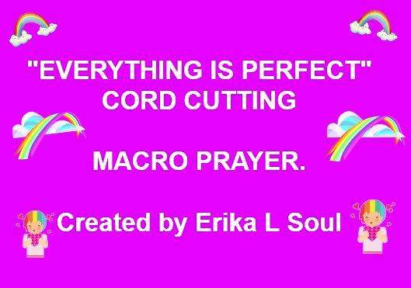
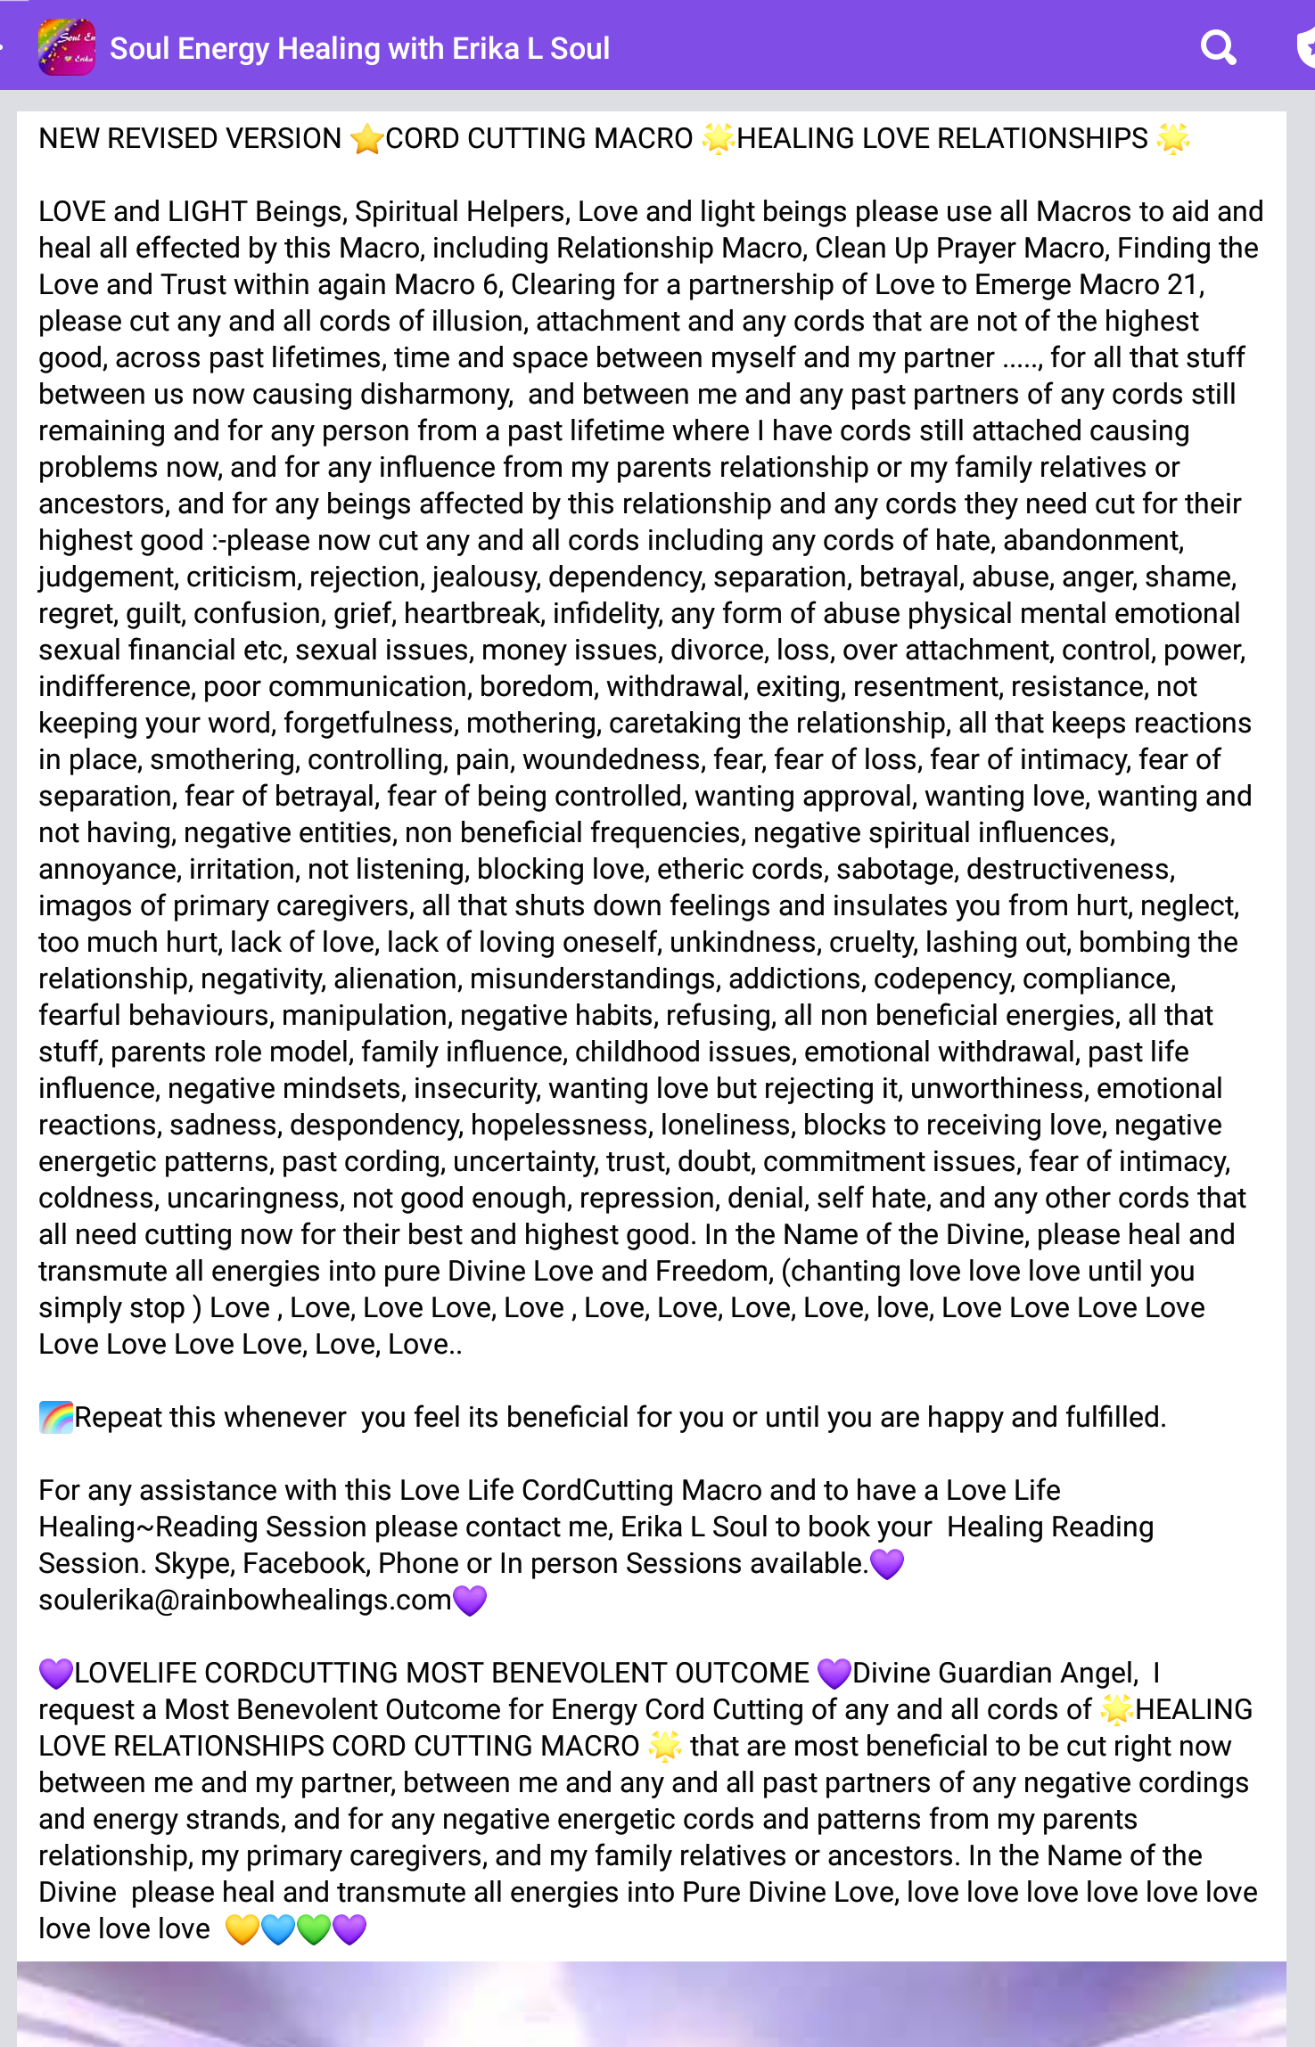

103.★ HEALING LOVE RELATIONSHIPS PRAYER MACRO ★
LOVE and LIGHT Beings, Spiritual Helpers, please cut any and all cords of illusion, attachment and any cords that are not of the highest good, across past lifetimes, time and space between myself and my partner ....., for all that stuff between us now causing disharmony, and between me any past partners of any cords still remaining and for any person from a past lifetime where I have cords still attached causing problems now, and for any influence from my parents relationship or my family relatives or ancestors, and for any beings affected by this relationship and any cords they need cut for their highest good :-please now cut any and all cords including any cords of hate, abandonment, judgement, criticism, rejection, jealousy, dependency, separation, betrayal, abuse, anger, shame, regret, guilt, confusion, grief, heartbreak, infidelity, any form of abuse physical mental emotional sexual financial etc, sexual issues, money issues, divorce, loss, over attachment, control, power, indifference, poor communication, boredom, withdrawal, exiting, resentment, resistance, not keeping your word, forgetfulness, mothering, caretaking the relationship, all that keeps reactions in place, smothering, controlling, pain, woundedness, fear, fear of loss, fear of intimacy, fear of separation, fear of betrayal, fear of being controlled, wanting approval, wanting love, wanting and not having, negative entities, non beneficial frequencies, negative spiritual influences, annoyance, irritation, not listening, blocking love, all that exiting and separating from each other, all that causes me not to see my partner as the perfect divine being he/she is, etheric cords, sabotage, destructiveness, imagos of primary caregivers, all that shuts down feelings and insulates you from hurt, neglect, too much hurt, lack of love, lack of loving oneself, unkindness, cruelty, lashing out, bombing the relationship, negativity, alienation, misunderstandings, addictions, codepency, compliance, fearful behaviours, manipulation, negative habits, refusing, all non beneficial energies, all that stuff, my parents role model, family influence, childhood issues, emotional withdrawal, trapped emotions, past life influence, negative mindsets, insecurity, wanting love but rejecting it, unworthiness, emotional reactions, sadness, despondency, hopelessness, loneliness, blocks to receiving love, negative energetic patterns, past cording, uncertainty, trust, doubt, commitment issues, fear of intimacy, coldness, uncaringness, not good enough, repression, denial, self hate, and any other cords that all need cutting now for their best and highest good.
In the Name of the Highest Divinity, please heal and transmute all energies into pure Divine Love and Freedom, thankyou thankyou thankyou, (chanting the word ) Love , Love, Love Love, Love , Love, Love, Love, Love, love, Love Love Love Love Love Love Love Love Love Love love Love

Say this prayer out loud and then after a while you will simply just ask to cut the cords of HEALING LOVE RELATIONSHIPS CORD CUTTING PRAYER...and it is done without the whole prayer being said. If you don't do this cordcutting outloud it won't be as effective a healing for you.
SHORT FORM after you have chanted the long form a number of times:
I ask any and all Beings, Archangel Michael, Archangel Raphael , Mother Mary, Archangel Uriel, Archangel Chamuel, all those aiding and assisting me spiritually, please cut any and all cords of ★ HEALING LOVE RELATIONSHIPS★ CORD CUTTING MACRO PRAYER between me and my partner now, and between me any past partners of any cords still remaining and for any person from a past lifetime where I have cords still attached causing problems now, and for any influence from my parents relationship or my family relatives or ancestors. In the Name of the Highest please heal and transmute all energies into Pure Divine Love, love love love love love love love love love ……………..
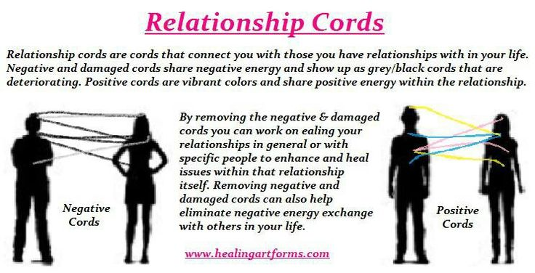

73. BE SET FREE FROM PAIN MACRO PRAYER

You can cut the cords with this Macro by reading this and stating it all completely and then you can progress to just stating the title BE SET FREE FROM PAIN holding the intention of Cord Cutting for it all for yourself or another, and you can chant the word Love continuously until your voice stops, as a way to know when its done. Cut the cords anytime you have any pain or soreness or emotional or mental pain ie suffering of any kind, you can’t overuse it and each time what is ready to be cut is done so more and more is released back into Love. Any help you need with using this or to book a session directly with me over the phone skype facebook video or in person please contact me via my website Erika L Soul www.rainbowhealings.com

*BE SET FREE FROM PAIN* MACRO PRAYER* by Erika L Soul

Love and Light Beings, please include all appropriate beneficial Macro’s and aid and heal all affected by this Macro. Please cut any and all cords across lifetimes time and space and dimensions with all negativities/attachments between myself and all: self created pain, painful memories, physical pain, mental pain, emotional pain, heartache pain, traumatic experiences, punishing self with pain, self sabotage created pain, relationship pain, family pain, addiction to pain, karmic pain, self inflicted pain, any pain from any form of abuse, all illusions of pain, all stored pain, pain body, attachments to pain, wanting pain not wanting pain, resistance to pain, avoidance of pain, any pain you have taken on from others, belief about pain, all not being able to release pain, feeling tortured, all negative events causing present pain, inevitability of pain, all beliefs causing pain, inflammation in the body, all trapped emotions causing pain, all need for pain, painful thoughts, worry and fear about pain in the body, all stress related pain, never ending pain, neck pain, back pain, foot pain, pain in head, all pains in the body, chronic pain, no escape from pain, obsession with pain, fear and doubt, disempowered, how to end the pain, negative thoughts and feelings causing pain, using pain as a distraction, all wanting to relieve other peoples pains, addicted to pain, addictions, the journey of pain, taking on others karmic burdens, all need for attention, sympathy, wanting to be cared for, needing others, dependency, pain medications, controlling pain, lack of understanding the true cause of your pain, allowing pain, letting go of pain, freedom, control, power, hopelessness, brain imbalances, brain function optimisation, dehydration, resistance to drinking water, chemical imbalances, hormonal imbalances, pessimism, negative states of consciousness, unhappiness, misery, self hate, wanting to get out of this life, fighting pain, giving your power to pain, fearing pain, the pain body, not loving self, hate, anger, fear, taking on others pains pathways realities, wanting to stop the pain others are experiencing and taking it on for them, too much suffering, pain is a necessary evil, all blockages, all stagnant energies, all allowing life to flow with ease joy and glory, all aches and pains, work pain, all ill effects of pain on the mind body emotions spirit, all debilitating effects of pain, no one understanding the pain you are in, wanting to find the way out of pain, wanting to be whole healthy and at ease and happy again, your whole relationship with pain, all causes of pain on all levels, loving pain, all that stuff unexpressed unacknowledged that the body is now expressing as pain to release the burden, total detachment from pain, feeling the sunshine and joy and happiness always available, allowing in Healing Energy throughout the body, healing the root source cause of pain, being empowered to heal and cure pain, transcending pain, being at peace, letting go and letting God, loving the body, loving self, loving life, loving the Source of all Life, dwelling in the highest state of Love, forgiving all, forgiving self, forgiving everything, release and freedom, accepting the highest Divine Truth.
In the name of God please heal and transmute all energies into pure Divine Love, thanks Be. Love Love Love Love Love Love Love Love Love Love Love.

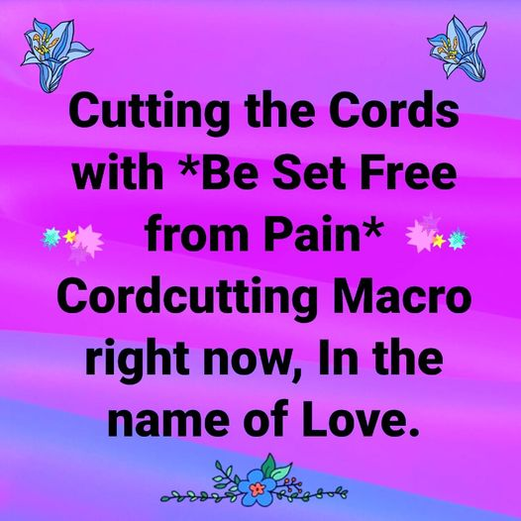
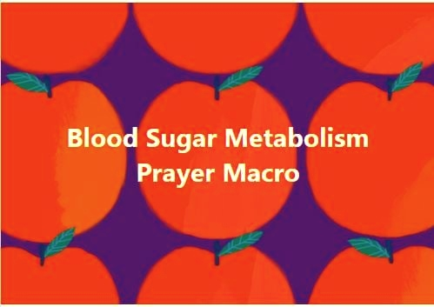

99. Blood Sugar Metabolism Prayer Macro .
Love and light Beings please use all Macros to aid and heal all effected by this Macro,(including Addictions Prayer, Body Prayer, Allergies Prayer, Food Prayer, Digestion Prayer, Super Brain Health Prayer, and all ever cut for this in the BarbBall) please cut the cords of any negativities/ attachments between me and my body and with anything adversely affecting my blood sugar metabolism and my having balanced healthy blood sugar levels, with all symptons of blood sugar imbalances, with all fears and worries about my blood sugar and my health, cutting the cords with everything Blood sugar related, low blood sugar, hypoglycemia, diabetes, all involved adversely affecting blood sugar levels, diet, foods, drinks, stress, brain health, memories, trauma, abuse, past life factors, inherited factors, beliefs, emotions, all causing any ups and downs with blood sugar levels, all moods, all pathogens, all blood sugar imbalances affecting my brain, all in the body being affected by blood sugar imbalances, insulin production, liver, pancreas, all organs involved, all resulting symptons and health problems resulting from faulty blood sugar levels, with all forms of sugar and with syrupy substances, with all cravings for sweets and sugar and foods that bring the blood sugar up and then down, all highs and lows, all alcohol caffeine, white refined foods, all taken on from others, balancing the blood sugar and body and bringing about a very good healthy blood sugar metabolism. In the Name of Love, please heal and transmute all energies into pure Divine Love, Love Love, Love, Love chanting love until your voice fades.

*********************************************

76. PROCRASTINATION BUSTER MACRO PRAYER

Love and Light Beings Please use all Macro’s to aid and heal all affected by this Macro, including the Macro’s “Why put off until tomorrow what I can enjoy today” and “Taking Action with Love”, please cut any and all cords of illusion, cords of attachment, cords not of the highest good, across the lifetimes, time and space, between each individual and all of this Macro according to the highest order of needs upon their request of this Macro; All procrastination, I don't want to when I should, shrugging off responsibilities, sabotage, delaying my work, ignoring what needs to be done, postponement, obstruction my progress, hindering, holding back my work, dawdling, faltering, fumbling, hesitancy, indecision, reluctance, unwillingness, wavering too much, research is one of procrastination's most elegant disguises, making excuses, balking, making bottlenecks, choking, delaying, frustrated, stymied, thwarted, making obstacles, interfering, interrupting, hampering, freeze up, shut down, stall obstacles to prevent progress, roadblocks, barricade, distracted by crazy makers, victim mentality, fear of success, inertia, negative force, negativity, negative self talk, clogs in the flow, creating hurdles, Self Punishment, emotional stress , suffering, torture, chastisement, lack of freedom, limiting self, self research is a form of procrastination needing to be loved, boldness, mood stability, clarity and focus, communication skills, compulsiveness, lack of concentration, concentration issues, confidence in self,self trust, being stuck in inaction, self control, creativity, all blocking your creativity, defense mechanisms, keeping agreements with self and others, breaking commitments, being committed, doing what you say you will do, success in any endeavour, drifting, ego, emotional issues, unworthiness, lack of energy, perfectionism, fear of own greatness, self image, flexibility, fear of making mistakes, pain, fear of love, fear of fame, irritability, irrational lies issues, learning abilities, lack of forgiveness of self and others, insecurities, fears, lack of awareness, separation from self, separation from soul, interference with souls desire, mental issues, negative emotions, obsessiveness, fear of people, fear of punishment, motivation, negative attitudes, completing tasks, wandering thoughts, weakness, problem solving, brain balance, brain function, discipline, dedication, stamina, resistance to negativity, responsibility, negative concepts of self, attachments, fear of change, pressure, fear of pressure, fear of judgement, fear of ridicule, anxiety, work ethics, hormones, self abuse, abuse from others, persecution, self punishment, brainwashed mentalities, trapped emotions, self hate, self sabotage, self loathing, self disgust, not wanting to succeed, wanting to succeed, acquired belief structures, adequacy, aggression, poor attention, bad habit issues, balanced mind set, I can do it, I can't do it, it’s too hard, it’s too much work, resistance to delaying and procrastinating, resistance to not doing things, resistance to getting things done, past trauma, if I succeed I might die or be killed, fear of death, divine order, disharmony, divine harmony, chaos, all those vibration locks, all that putting your foot on the brake and then going nowhere and getting frustrated, all that frustration and anger, hating what is and hating what isn't, all that you get out of putting things off, inherited patterns, inherited keep yourself small syndrome, fear of reaching big heights and then falling, judging where you and where you are not, not giving yourself credit for what you have achieved, self approval, wanting disapproval, wanting to be seen and not wanting to be seen, all conflict creating procrastination, how all that procrastination is serving you, not seeing yourself as the Divine does, letting yourself be controlled by your attachment to getting over your procrastination and never getting over it, all the ways procrastination is serving you, not seeing the gift in your procrastination, all disallowing your good, all disallowing divine inspirations to come through you, all memories replaying, all data, all that you are being capable of being now, all time issues, all must get it done issues,all feelings and thoughts of wasting time, time and space and communication, negative opinions, negative thinking, all being caught in a trap, all that circular logic, all going round and round with the same thoughts, all distractor implants, all issues of control and power, all choices that lead you to your highest destination, all that wants to be born through you now, allowing Love, being empowered to take Inspired Action, unconditional love of self, self forgiveness, allowing everything, being One with all that IS, letting go and letting God, thankyou God.
Thanks Be, in the name of the Highest Divinity, please heal change transmute all energies into Love Love Love Love Love Love Love Love Love Love Love Love Love Love Love Love Love Love Love Love Love Love Love Love Love Love Love Love Love Love Love thankyou thankyou thankyou.

HEALING AFFIRMATION
All I am is eternal as soul, I am divine Love. Where I am now is perfect, how I am now is perfect, there is nothing I need to change. It is so easy for me to have be and do anything I desire, I am fulfilled and happy in this moment.

INFO
After you read the Macro and know what is in it and you have cut cords with it many times while reading it you can just say Cut the cords of the ‘PROCRASTINATION BUSTER ‘ thankyou. Cut the cords of this Macro anytime you feel unclear and in resistance to something you are not being or doing. To cut the cords simply state outloud as you read it all and ask for it all to be cut for you as you read it or say it all silently .

I have created this Macro to aid in cutting cords with PROCRASTINATION, and I have utilised Alyssa Mary Rose’s Abundance of Light Cordcutting technique which is what I use as an advanced cordcutting technique, having learnt and used this method since 2003. I have worked with many other types of cordcutting techniques however this one has been my main method for many years.

77. BEAUTIFUL SKIN PRAYER CORDCUTTING MACRO
For those who love Cutting Cords with Abundance of Light Macro Prayers, I have created Beautiful Skin Prayer Macro. Beautiful Skin Prayer is for cutting cords with all skin conditions and all that involves the Skin i.e. self image, skin aging, scars, blemishes, rashes, age spots, sensitive skin, skin lesions, skin health, acne, skin diseases, skin complaints, touch, all problems involving the skin, how we think feel talk about our skin, any damage to the skin, any physical harm by another person, all to do with the skin layer of the body .
To cut cords with this Macro just use the title of it and ask to cut all cords between you and what your concern is with the Macro name and keep it simple and short....
Erika L Soul~ Healing Angel Ministry

BEAUTIFUL SKIN PRAYER CORDCUTTING MACRO

Love and Light Beings please use all Macro's to aid and heal all affected by this Beautiful Skin Prayer Macro. Love and Light Beings please cut any and all cords of negativity, attachments between me with any skin complaints, skin damage, self image, skin aging, scars, blemishes, rashes, age spots, sensitive skin, skin lesions, skin health, acne, skin diseases, touch, all problems involving the skin, how we think feel talk about our skin, any damage to the skin, any physical harm by another person, everything to do with the skin layer of the body, perfect healthy skin, and with all that is included in Beautiful Skin Prayer, In the name of the Highest please heal and transmute all energies into pure Divine Love. Chanting In the Name of Love..Love Love Love Love Love Love Love Love Love Love Love Love Love Love Love Love



*80. STOP BEATING MYSELF UP OVER PAST MISTAKES PRAYER MACRO

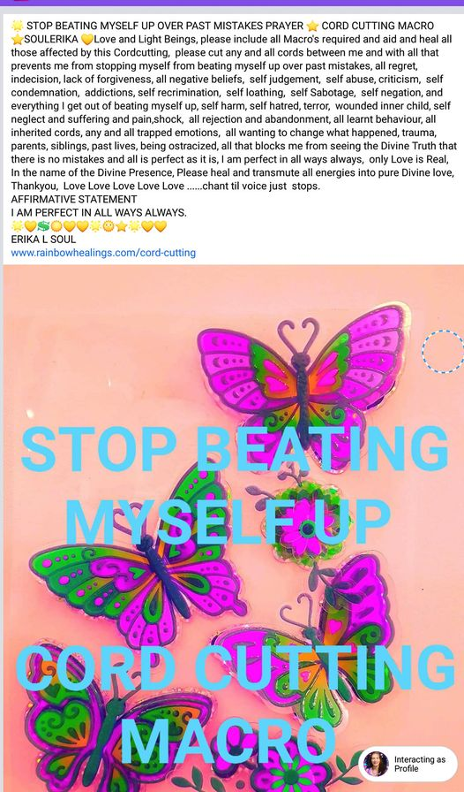

*102. LET’S CLEAN UP OUR ACT FOR DIVINE ILLUMINATION MEGA MACRO PRAYER
A huge Mega Clean Up Prayer for cutting the energy cords of negativities/attachments to being able to stay being true to ourselves in our interactions with others, being empowered and confidant, not resisting or reacting or agreeing with them and being free from fears and negative expectations of people and situations. Also cleans up places we shop at or spend time in like our homes and workplaces, our energy field, all the ways we get caught up in the trap of the negative force and then judge ourselves for not being more spiritually perfect. Any attraction to negativity and all the ways non beneficial energies gain access to us and our homes and spaces we are in, all lack and limitation of having enough and fear of not having what we need.
This Mega Macro includes many big Macro Prayers, including Squeaky Clean Mega Macro, Peace Prayer, Fear Illusion and Phobia Prayer, Self Sabotage Prayer, Perfect and Divine Order Prayer, Relationship Prayer, Spirit Mega Macro, Changing Negativity, Addictions Prayer, Healing Judgement and Unforgiveness Prayer, Healing Friends Prayer, Power Over Prayer and Powerlessness Prayer, Healing Abuse Prayer, and all Macro’s required to aid you in keeping your spiritual balance being a channel for Divine Spirit to flow through you to all around you.

To cut cords with this simply read the above and then do the wording of Love and Light Beings please cut the cords of Let's Clean Up Our Act Prayer Macro between me and ......
Then chant "In the Name of Love, In the Name of Love, In the Name of Love, In the Name of Love, In the Name of Love, In the Name of Love, Please heal and change any energies released back into Love, Love Love Love Love Love Love.

In my facebook group Soul Energy Healing with Erika L Soul this Macro was created in a group facebook live video session 18, so you can watch it in the group and receive this cordcutting facilitated for you if you are a member and on facebook. https://www.facebook.com/1080747677/videos/10222131907701611/

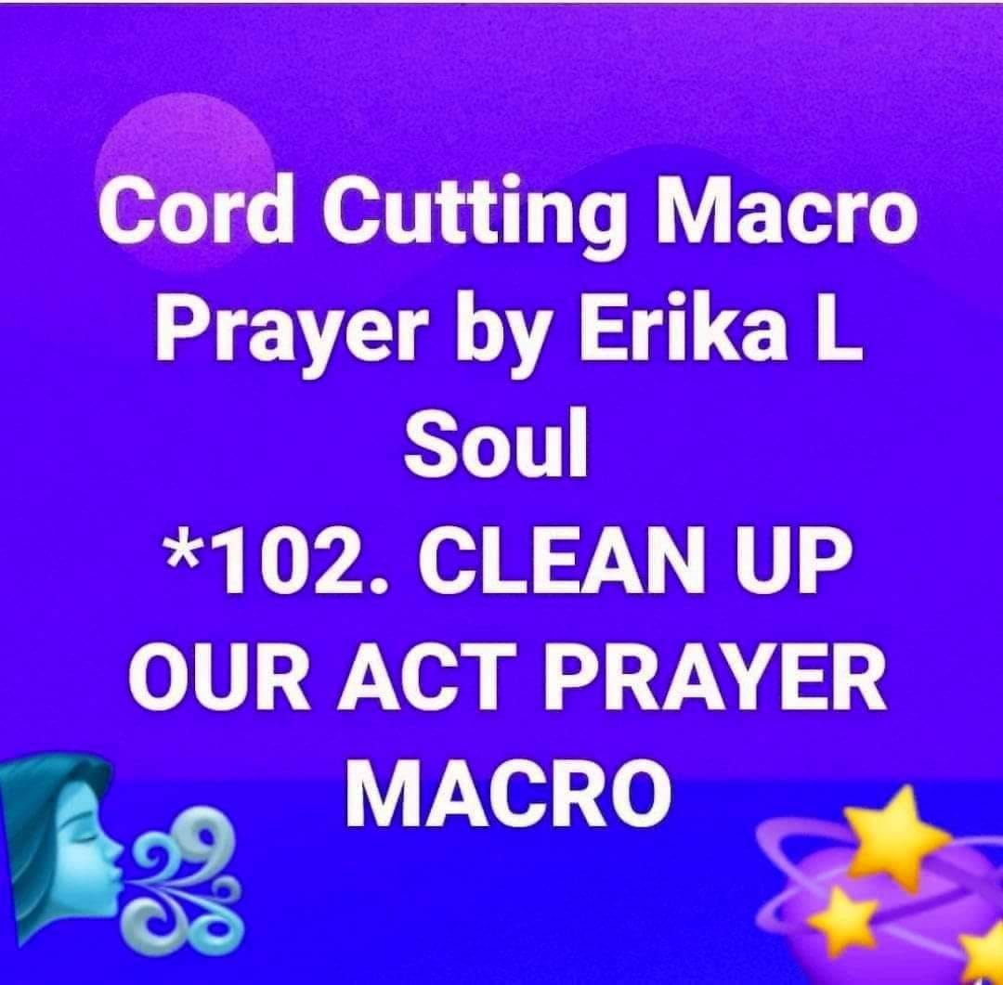

ERIKA L SOUL’S MACRO CO-CREATION’S [THIS LIST IS FROM MY DOCUMENT FILE COMMON LIST MACRO’S ]

This list does not include full wording of each Macro Prayer however I have included them for your use and this is the latest version of my Macro Prayers and as new ones pop up frequently and are added to it. All the wording that exists for them is in this file. Please note you do not need to know what is included in the wording just cut cords with the title and your own issue relating to it. Contact me for a private session to learn more and receive cord cutting session costs are on my website.
---------------------------------------------------------------------------------------------------------------------------------------
71. PROSPEROUS BUSINESS MEGA MACRO- All the Macro's related to Business and Money Prosperity and Success and Achievement.
72. PROSPEROUS SUCCESSFUL HEALING PRACTICE MEGA MACRO - All the Macro's relating to having a successful thriving Prosperous Healing Practice and Business, and including all the Macro's related to being a healer, and all Macro's on the list.
*73. BE SET FREE FROM PAIN MACRO PRAYER - Cut the cords with all pain and that is causing the pain and your whole relationship with pain.*
*74. CHANGING NEGATIVITY PRAYER MACRO- Cut cords with all that negativity you are experiencing and all habits of negative thinking and feeling.*
*75. EVERYTHING IS PERFECT PRAYER MACRO- Cut cords with all that stuff with Corona Virus and all to do with it going on for you and with the world and local situations. *
*76. PROCRASTINATION BUSTER PRAYER MACRO - Bust free from all that procrastination and all the cords creating it within.*
*77. BEAUTIFUL HEALTHY SKIN PRAYER MACRO- Cut cords with everything connected to your skin, all ailments, all with its appearance, and all that stuff around skin and beauty.
*78. ETERNAL MEMORY PRAYER MACRO- have a perfect memory and recall instantly, includes all Macro's relating to memory, brain function and brain health.
*79. HEALING ABUSE PRAYER MACRO- healing all abuse patterns and memories of abuse, from being abused or being the abuser from any lifetime, including all the Macro's related to Abuse.
*80. STOP BEATING YOURSELF UP FROM PAST MISTAKES PRAYER MACRO- name says it all.*
*81. MOVE INTO YOUR GREATNESS PRAYER MACRO- name says it all, cut the cords of all in the way of your embodying your greatness. *
*82. STOP YOUR COMPLAINING PRAYER MACRO* Includes all macro's related to complaining, cut the cords of all that habit of complaining and all that causes it, all negative critical states of mind.
*83. CUT THE CORDS WITH CHRISTMAS PRAYER MACRO* Be free to celebrate Christmas in the way that you enjoy, cut all cords with Xmas past and present with every aspect of Christmas, food, family, money, shopping, work, time, expectations etc. *
*84. PETS & ALL CREATURES HEALTH WELLBEING MACRO PRAYER - All Macro's related to pets, animals, all creatures great and small, all that is affecting the creature’s perfect health and happiness and wellbeing, includes everything to do with caring for your pet and your relationship to it, all health related issues and its happiness.
*85. CUTTING CORDS WITH THE ABUNDANCE OF LIGHT CORD CUTTING TECHNIQUE MACRO PRAYER - Cut the cords of any stuff you have with using this technique, does it really work, how long to chant, what Macro to use, all with understanding it, learning it, how to do it, your relationship with this technique so you are free to become happy and confidant doing the cordcutting with anything for anything and for anyone. Includes all Macro's related to cord-cutting with this wonderful Abundance of Light Healing technique.

*86. PERFECT EYE HEALTH & VISION MACRO PRAYER
A great eyesight eyehealth Macro to cut cords with for any and all eyesight problems and anything to do with the eyes, eyelids, spiritual eye, addressing all eye damage, all that is connected to your health and eyes ie memory and imagination, neck, memories, inherited factors all eye conditions, all that has caused problems with the eyes. Cutting all cords in the name of the Divine healing transmuting all energies into Love Love Love Love Love Love.

*87. ENLIGHTENMENT PRAYER MEGA MACRO- This Mega Macro contains all of the Macro’s that work towards enlightenment, including Spirit Mega Macro, Unfoldment Mega Macro, Light of Life Mega Macro, Light of Life Mega Macro, Higher Self Prayer Macro, Divinity Prayer Macro, Divination Prayer Macro, all Macro Prayers that exist and individual cord cutting prayers and all that has been cut so far clearing the path to Self Realisation, and God Realisation, Enlightenment, reaching your Spiritual goals, becoming Enlightened with God, spiritual mastery, a coworker with God, total awareness of God and spiritual Truth. Cutting all cords in the name of the Divine healing transmuting all energies into Love Love Love Love Love Love.

*88. PERFECT DIVINE ORDER MACRO PRAYER –includes all Macro Prayers (Disorganisation Buster) and all Cords cut in the Barb Ball relating to Being Clear, Grounded, Organised, Balanced, inner Harmony, focus, being in perfect and divine order, clutter, chaos, disorganisation, memory, mind clutter, physical clutter, emotional and mental clutter, control, scattered, lost, disconnected, mess, hating mess, hating untidiness, obsessiveness, phobia’s, fear, tidiness and cleanliness, being in the perfect place at the right time, listening and following our inner guidance, clarity, clear thinking, steadfastness, dust, germs, inner calm and inner peace, conflict, discord, unforgiveness of self and others, power, etc etc. Cutting all cords in the name of the Divine healing transmuting all energies into Love Love Love Love Love Love.

*89. DIGESTION PRAYER MACRO- Includes all Macro’s relating to digestion (Food Prayer, Addictions Prayer, Crutches Prayer, Body Prayer, Weight Prayer, Chakra Prayer and Clean Up Prayer) cutting all cords with Digestion, indigestion, gut problems, nutrition, absorption, stomach, solar plexus chakra, stress, personal power, confidance, food and nutrition, gut health, all stomach ailments, all cords to others connected in via the stomach, childhood food issues, food comfort, eating to satisfy unmet needs, etc etc. Cutting all cords in the name of the Divine healing transmuting all energies into Love Love Love Love Love Love.

*90. HEARING & EAR HEALTH MACRO PRAYER – Includes all Macro’s related to ears and hearing and all cords previously for ears and ear health and hearing related disorders. Whatever the issue is the ears this Macro has it included, hearing, ears, ear health, ear conditions, ear damage, hearing difficulties, the inner ear, hearing sound, hearing pitch, hearing what we don’t want to hear, blockages to hearing well, inherited ear problems, spiritual causes of ears and hearing difficulties, tinnitus, ear infections, cutting all the cords of all issues with ears and hearing for all time space dimensions etc. Cutting all cords in the name of the Divine healing transmuting all energies into Love Love Love Love Love Love.

*91. CLIENT SESSION CLEAN UP PRAYER MACRO- All Macro’s relating cleaning up energies from doing a session with a person, soul fragments exchanged, all that needs resolving, clearing, healing, all issues and concerns, Customer Prayer, all Purifying Cleansing Macro’s, all cords cut within the Barb Ball, all conflicts, healing tools and methods utilised in the session, all money and energy exchange, all the session brought up for the practitioner that relates to the client, all triggers, shared memories, beliefs, negative energetic patterns, all behaviour, all doubt about the session being effective and healing being conducted, all with the outcomes, all attachments, etc etc etc. Cutting all cords in the name of the Divine healing transmuting all energies into Love Love Love Love Love Love.

*92. POWERLESSNESS PRAYER MACRO – ALL Macro’s related to powerlessness, all cords cut in the Barb Ball related to Powerlessness, victimhood, oppression, all giving power away to anything or anyone or anyplace, all illusions of not having power, all abuse of power, all giving away your power for whatever reason, disempowerment, needing power, lack of power, helplessness, hopelessness, what’s the use, all diminishing self, inner child, fighting conflict slavery control hatred blame judgement criticism self abuse, authority, fear of annihilation, manipulation, giving up, being under attack, imprisoned, rejection of power, defencelessness, resistance, lost to self and God, depression, suicide, approval seeking, Cutting all cords in the name of the Divine healing transmuting all energies into Love Love Love Love Love Love.

*93. SUPER BRAIN PRAYER MACRO - Cutting cords with everything that relates to the brain, all Macro’s related, all cords cut in the Barb Ball, Brain health, brain function, including all in the Remembrance Prayer Macro, all brain health disorders, all that is adversely affecting the brains function and health, all that is in the ELS Brain Balance Healing Dowsing protocol, creating a healthy vibrant super brain, brain balance, blood sugar balance, hydration, golden light healing flowing through the brain.

*94. ALLERGIES PRAYER MACRO- All allergies, intolerances, sensitivities to anything or anyone, any substance, all toxins, all harmful substances, all pollutants, all chemicals, anything you react to, all fear of having a reaction all fear of something that will harm you, including all Macro’s required and healing all affected by this Macro, all causes of negative responses, all inherited causes past life, all symptons, skin related allergies or sensitivities, all pain and inflammation, all limitations related to intolerances, all memories, all negative expectations, all emotions involved, beliefs and thoughts, everything involved and causing the intolerance on any level, all addictions to the intolerance, all resistance, all pains involved, trauma, memories etc.

*95. BACK /NECK/ SPINE PRAYER MACRO – All that’s causing back problems, all cords needing cutting, all not yours, all pain, all that’s connected to the back problem, any damage to the spine, posture, inherited, all suffering, all memories, including all Macro’s to aid and heal, anything connected to the back like neck, hips, stomach area, muscles affecting the back, all support issues, all control issues, all treatments, all practitioners involved in back care, injuries, surgeries etc.

*96. FEET/ANKLE PRAYER MACRO – Cutting cords with all feet conditions, all problems with the feet, all pain, inflammation, arthritis gout etc, all difficulties with walking standing being mobile, including the ankles, bones ligaments tendons, tissue, fascia, toes, skin problems, swelling, all that is concerning you regarding your ankles and feet, all injuries, fractures, surgeries, all past life and inherited feet problems, all beliefs thoughts memories affecting the feet, all treatments, podiatrists, surgeons, how to have better feet, all problems caused by footware, socks, not walking properly, exercise and fitness, weight issues affecting feet, etc etc. all cords cut in Barb Ball re feet and ankle, all Macro’s needed etc. thankyou.

*97. HEALING JUDGEMENT & UNFORGIVENESS PRAYER MACRO – cutting cords with judgement of self and others, unforgiveness, unkindness, cruelty, lashing out, self Sabotage due to self judgement that you have, failure and success, not achieving wanted outcomes. ETC. All Macro’s required and all cut for this in the Barb Ball.

*98. YOUTHFUL VITALITY MEGA MACRO PRAYER- This Macro Prayer contains all of the Macro’s that work towards Youthening, including Aging Prayer, Body Prayer, all Health related Macro’s, all to do with Mobility, Pain Healing Macro, etc and all cords that have been cut related youthening in the BarbBall, all our programming for aging in the body and all we have bought as real and true about aging, all our beliefs and memories, all trauma and abuse involved in our aging, and negative emotions about growing older, all fears worries about aging, all lack and limiting beliefs with aging, what we can do and can’t do, all our negative expectations around aging, fear of loss of our beauty and looks, fear of loss of mobility and agility, etc etc, everything is included in this Macro. So simply say Love and Light Beings please cut the cords of Youthening Mega Macro with all cords of negativities and attachments between me and my body and aging and being youthful and all I have concerning me right now and affecting my youthfulness and health, thankyou, In the name of the Divine please heal and transmute all energies into pure Divine Love, Love Love Love Love Love Love Love…..continue until your voice fades and no more energy.

*99. BLOOD SUGAR METABOLISM PRAYER MACRO
Love and light Beings please use all Macros to aid and heal all effected by this Macro,(including Addictions Prayer, Body Prayer, Allergies Prayer, Food Prayer, Digestion Prayer, Super Brain Health Prayer, and all ever cut for this in the BarbBall) please cut the cords of any negativities/ attachments between me and my body and with anything adversely affecting my blood sugar metabolism and my having balanced healthy blood sugar levels, with all symptons of blood sugar imbalances, with all fears and worries about my blood sugar and my health, cutting the cords with everything Blood sugar related, low blood sugar, hypoglycemia, diabetes, all involved adversely affecting blood sugar levels, diet, foods, drinks, stress, brain health, memories, trauma, abuse, past life factors, inherited factors, beliefs, emotions, all causing any ups and downs with blood sugar levels, all moods, all pathogens, all blood sugar imbalances affecting my brain, all in the body being affected by blood sugar imbalances, insulin production, liver, pancreas, all organs involved, all resulting symptons and health problems resulting from faulty blood sugar levels, with all forms of sugar and with syrupy substances, with all cravings for sweets and sugar and foods that bring the blood sugar up and then down, all highs and lows, all alcohol caffeine, white refined foods, all taken on from others, balancing the blood sugar and body and bringing about a very good healthy blood sugar metabolism. In the Name of Love, please heal and transmute all energies into pure Divine Love, Love Love, Love, Love chanting love until your voice fades.

*100. TIME & SPACE PRAYER MACRO
Cutting with all the cords regarding time and lack of time too little time, wasting time, rushing, tension, hurrying, being in harmony with time and in divine time. How long you live, what age you are, what you do with your time here on earth. Being too fast or too slow. Etc.
*101. SOULMATE PARTNER PRAYER MACRO
Cutting the energy cords of negativities attachments that prevent you from having the soulmate spiritual partner love relationship you desire, all the dreams and desires you have for a love partner that is a vibrational match for you and that you are right and perfect for each other,helping to bring you together, on the checkerboard of life. Includes all Macros and cord cutting that work towards you having the fulfilling love relationship your heart and soul desires.

*102. DIFFICULT PEOPLE PRAYER MACRO
A huge Clean Up Prayer for cutting the energy cords of negativities attachments to being able to stay being true to ourselves while with others, being empowered and confidant, not resisting or reacting or agreeing but being free from fears and negative expectations of people and situations, also cleans up places we shop at or spend time in like our homes and workplaces, all the ways we get caught up in the trap of the negative force and then judge ourselves for not being more spiritually perfect. This Mega Macro includes many big Macro Prayers, including Squeaky Clean Mega Macro, Peace Prayer, Self Sabotage Prayer, Perfect and Divine Order Prayer, Fear Illusion Prayer, Phobia Prayer, Relationship Prayer, Spirit Mega Macro, Changing Negativity, Addictions Prayer, Healing Judgement and Unforgiveness Prayer, Healing Friends Prayer, Power Over Prayer and Powerlessness Prayer, Healing Abuse Prayer, and all Macro’s required to aid you in keeping your spiritual balance being a channel for Divine Spirit to flow through you to all around you.

103. HEALING LOVE RELATIONSHIPS PRAYER MACRO
Cut the cords with this Macro for any relationship past or current with a partner, lover, boyfriend, spouse, TO see the details see the full Macro in this file.

104. SELF LOVE PRAYER MACRO- The name says it all, cut the cords with this powerful macro prayer to realise your own self love in existence all along within you, clear the crud blocking self love, included are all cords cut with self love in the Barb Ball, all Macro’s that work towards self love are included in this Prayer. Two sessions have created this divine Prayer that helps you on your spiritual journey into Self Realisation, loving self and others, knowing your own essence is Pure Love.

105. DEEPEST TRUTH PRAYER MACRO
What is the truth ? How do we access the Truth within us ?? How to discern truth from lies manipulations illusions. All and our resistance to knowing and realising Truth, self denial of truth, fighting for whose truth is the truth, our viewpoints and opinions, everything we decide is the truth
and make it our belief. And the Truth shall set us free. Included in this Macro are all cords cut relating to Truth from the Abundance of Light Barb Ball and all Macro Prayers and cords cut relating to Truth. Anytime you are unsure of what the truth is, have doubt confusion, resistance, fear, anger, simply Cut the Cords of The Deepest Truth Prayer Macro between you and what you are experiencing.

106. I WANT TO BREAK FREE MACRO
Love & Light Beings, Please include all Macro’s needed and heal all those affected by this Macro, please cut the cords of any negativities/attachments between myself and any family woes, healing from suicide, healing me of the effects of all vows taken in this life time or earlier, for healing all my previous lifetimes & this life time traumas, negativities that no longer serves me; Cord cutting of anything not useful effective and enjoyable I release loose and let go to go confidently forth in a circle of LOVE to live a life of rich lavish abundance and health and wellness, self-sabotage and struggle, low self concept, my abundance and luck, organisation, Self Love, Self Acceptance, free from others judgement, being aware of the Truth of my own Divinity, Busting Loose from FEAR, all vows not serving me anymore I have made in the past, anything not useful effective and enjoyable I release loose and let go to go confidently forth in a circle of LOVE to live a life of rich lavish abundance and health and wellness. Include Cutting the cords of all Macro's cut in group session 24 we cut cords with, including Procrastination Prayer, Self Sabotage Prayer, Total Abundance Mega Macro, Self Love Prayer, Self Acceptance Prayer, Inner child Healing Prayer, Fear Buster Macro of the Moment, healing Judgement and Unforgiveness, Changing Negativity, Just Clear the Lot God, Relationship Prayer, Prosperous Business Mega Macro Prayer, Clean Up Prayer, etc etc etc, In the Name of Love, Please heal and change any energies released back into Love, Love Love Love Love Love Love.

107. DIVINE INNER GUIDANCE MEGA MACRO PRAYER
Love & Light Beings, Please include all Macro’s needed and heal all those affected by this Macro, please cut the cords of any negativities/attachments between myself and including Divination Prayer, Divinity Prayer, Higher Self Prayer Macro, Unfoldment Prayer Macro, all Macro’s that have to do with inner guidance and our intuition, our knowing, our awareness, being tuned in and present, all with our minds being cluttered, and all exiting from this reality not being here fully so we are not listening and following our inner prompts, all wanting to escape from this reality, giving away our power our knowingness, exiting from ourselves and the Divine and others around us and going for distractions like tv, all escapism, all not facing our fears thoughts feelings pain and thus exiting abandoning ourselves and getting lost in distractions, all wanting closeness and all wanting to disconnect separate and judge, wanting to get away from it all, all confusion with what is our thoughts or others and what is the divine inner guidance, awareness of the Divine in ourselves, all blocks to hearing the voice of the Divine, making choices and knowing what to do, letting go and trusting in the Divine, all cords so far in the Abundance of Light Barb Ball re divine guidance, Chanting In the Name of Love, In the Name of Love, In the Name of Love, until we stop, Please heal and change any energies released back into Love, Love Love Love Love Love Love.

108. COMING HOME MACRO PRAYER
Love & Light Beings, Please include all Macro’s needed and heal all those affected by this Macro, please cut the cords of any negativities/attachments between myself and all the Cord Cutting done in this group session, all Macro’s cut with and created, including Divine Inner Guidance Mega Macro, Deepest Truth Prayer, all with accessing our inner guidance,going to others for their advice, all exiting and abandoning ourselves and others, all we distract ourselves from and don’t want to feel our stuff and deal with it, emotional trauma’s from any time, healing and changing any trauma in our cells into loving energies, any codependency, fear of being controlled or abandoned, anything adversely affecting our health, the outer reality governing us instead of our inner reality, any stuff we have bothering us on any level in this moment, cutting cords with all blocking our Divine Money Flows, cutting cords with receiving money from anywhere or anyone or anything, Total Abundance Mega Macro, having an abundance of everything we need, cutting with Fear Illusion Prayer, fears, reaching enlightenment and our divine realisation, Enlightenment Prayer Mega Macro, cutting cords with our pets and any issues they have or we have with them including Pets Health Wellbeing Prayer Macro, all cut for in this whole hour session, Chanting In the Name of Love, In the Name of Love, In the Name of Love, until we stop, Please heal and change any energies released back into Love, Love Love Love Love Love Love.

109. TINNITIS MACRO PRAYER
Love & Light Beings, please use all Macros to aid and heal all affected by this Macro, please cut the cords of any negativities/attachments between myself and any and all symptons of tinnitus, all sounds related to tinnitus in the ears , sound sensitivity, balance, all related symptons and causes, cut all cords that are affecting the ears detrimentally anything that needs to be cut to bring the ears and hearing back to optimal health, cutting cords with any specific symptons of Tinnitis , hearing, balance, brain connections, cutting with all that is in this Tinnitis Macro and Hearing and Ear Health Prayer Macro, also including all Macro Prayers beneficial to cut cords with, restoring optimal ear health and all in the body connected to the ears, all stress related to tinnitus, all resistance to the symptons, all negative emotions involved, all nerves involved, all tightness in the neck and tmj, building new brain connections, In the name of Love, In the name of Love, In the name of Love, In the name of Love, please heal and transmute all Energies into Pure Divine Love, thankyou, Love Love Love Love Love Love Love Love, Love And it is Done.

110. I AM ME AND ONLY ME PRAYER MACRO
I AM ME PRAYER MACRO cuts the cords of all that stuff not even yours. All that entangles you into others stuff is cut with. All the ties that bind you and keep you from being yourself. Cutting cords with the mass consciousness and your locality and your home family friends and work, all you pick up as yours and believe is yours. Clearing all not yours and transmuting all into Pure Love. Cutting cords with taking on others burdens problems and karma for them.

111. RESTORATION PRAYER MACRO
Cutting cords with all that is causing you to leave, exit. Restoring all that has been fragmented, cut off, repairing, revitalising, rejoining, reinvigoration, getting your mojo back, your crown on, back on your horse, in harmony and all put back together all fragments realigned into a better higher state, cutting all cords of negativities attachments causing you to not be yourself, off centre, lost, disconnected, traumatised, sabotaging self, dysfunctional, losing self. Restoring you fully and completely back into a whole complete being, upgraded, clear, rebooted, rebalanced, restored and reconnected, better than ever and Greater than Before, strengthened, shifted into a higher state of consciousness, more kind, loving and positive.

112. PERFECT HEALTH and IMMUNITY Prayer Macro
Cut the cords with all going on with the covid vaccinations for all variations of the CoronaVirus, with truth surfacing, for safe good covid flu vaccines, with all greed and big pharma making huge profits from worldwide vaccinations, the vaccine will make you safe, even though you can still catch it or pass it on, third world countries not being able to afford good safe vaccines, all that stuff going on for or against everything in the media and with others, having choice or not to have it, all fear, all fear of the vaccine, all fear of negative effects, all fear of not having it and getting covid flu, all conflict, what is true and not true, mistrust, propaganda, all issues with having it that you have, all you have bought not yours, will I or won’t I, doubt, indecision, trust, immune system, healthy cells, all issues and worry about health and how it may affect you short and long term, with anyone who has been healing from covid and its impact on their health and wellbeing, all fear of catching covid, all that stuff with having the vaccine be your protection, all propaganda about vaccines, governements mandating work vaccinations so workers have to have it across all occupations, people not wanting to be coerced and not given a choice for their body and health, govt bringing it into peoples bodies the virus, Including all cords cut that have been cut on this in the Barb Ball, all that has been included in this Macro, all Macro Prayers relevant, Empowerment Prayer, Everything is Perfect Prayer, Fear Illusion Prayer, Phobia Prayer, I am me and only ME Prayer Macro, Vibrant Health Mega Macro, Body Prayer, Allergies Prayer etc. Simply cut with this title and all cords that need cutting for you will be cut.

113. POWERHOUSE MONEY SESSION PRAYER MACRO
Love & Light Beings, please use all Macros to aid and heal all affected by this Macro, please cut the cords of any negativities/attachments between myself and money and all that was cut in the Session 29 & 30 Group Live CordCutting Session called Powerhouse MONEY Session Part 1 & 2 , including all that was cut cords with all Macro Prayers, with all that was facilitated in this session, so that all is being cut for me right now that is highly beneficial and benevolent for me right now, thankyou thankyou thankyou. In the name of Love, In the name of Love, In the name of Love, In the name of Love, please heal and transmute all Energies into Pure Divine Love, thankyou, Love Love Love Love Love Love Love Love, Love And it is Done.

114 WOMENS PRAYER MACRO
This Macro Prayer is a huge Macro for cutting cords with the issues women face in the home and in the world. Its for every female to cut cords with all the points of view limiting womens horizons and life. Freedom to be ourselves without fear of oppression of our Spirit. There is a lot in this Macro we cut as it was created within a group live video facebook session.

115. HAPPINESS PRAYER MACRO
Macro to cut cords with all that UNHAPPINESS all that's blocking the Sunshine for you, restoring your natural state of HAPPINESS. Including all that's been cut re happiness vs unhappiness in the Barb Ball and including all Macro's and single and group Cordcutting lists, including JUST CLEAR THE LOT GOD CORDCUTTING MACRO PRAYER and Ugly Feelings PRAYER Macro. Feel happy just being alive.

116. BEST DRIVE PRAYER MACRO
Love & Light Beings, please use all Macros to aid and heal all affected by this Macro, Including all cords cut in the Barb Ball re driving and travelling on roads all in the Driving Prayer Macro previously and currently added in. Please cut the cords of any negativities/attachments between myself and with driving and all forms of transport, all travel, driving, being a passenger, others driving, other drivers, all experiences with family members and partners in cars, accidents witnessed, car accidents, drunk drivers, careless drivers, dangerous drivers, anger, road rage, fear, frustration, all concerns, traffic, safety, road conditions, finding your destination, city and country driving, all panic, nervousness, traumatic memories and all trauma from cars and vehicles stored in body and mind, all abuse experienced while in vehicles, technology in cars, driving skills, confidance, good navigation skills, having fun while travelling, traveling in all
conditions, weather, road conditions, vision, negative energy in places streets freeways etc. Cutting all cords of any attachments and negativities with my own car or the family car and relationship prayer and clean up prayer and with everything going on with the car and myself all thoughts feelings of the car and driving in it all energies that need clearing and purifying daily, thankyou. Cutting with any cords to bring about peace, calm, trust and faith and good experiences in vehicles, being the driver of your life and vehicle, spiritual protection, knowing you are always safe protected and guided at all times while travelling, 100% energy enhancement for the car at all times I drive or am in mostly and full clean up prayer for all vehicles I am in at any time and my family. In the name of Love, In the name of Love, In the name of Love, In the name of Love, please heal and transmute all Energies into Pure Divine Love, thankyou, Love Love Love Love Love Love Love Love, Love And it is Done.

117.GETTING LIFT OFF PRAYER MACRO
LOVE & LIGHT BEINGS, Please cut any and all cords of negativity/attachments between ourselves and everything cut for in this group session 33, including brain health and function, self destructiveness, negative force, suicide and wanting to exit this reality, blood sugar metabolism, blame, resentment, resistance to change, all that unhappiness, self judgment and unforgiveness of ourselves and others, having your ideal partner, wanting but not having, all negativity, with healing the whole planet, with energy blocks in our inner bodies, and cutting cords with these Common Lost Macro's 93. Super Brain Prayer Macro, 61. Planet Ark Prayer Macro, 58. Creative Juices Mega Prayer Macro, 101. Soulmate Prayer Macro, 64.Total Abundance Mega Macro Prayer, 115.Happiness Prayer Macro, 7.Chakra Prayer, 38. Peace Prayer, 111.Restoration Prayer, 87. Enlightenment Prayer Macro. In the name of Love please heal and transmute all energies into pure Divine love, Love Love Love Love Love, Love, Love, Love, Love, Love.

118. IMMUNE SYSTEM PRAYER MACRO
Love and Light Beings please cut any and all negativities attachments with all that is adversely affecting the Immune system, please use all Macros to aid and heal all affected by this Macro, including Allergies Prayer, Body Prayer and all cords cut for the Immune System and the Nervous System in the Barb Ball, cut the cords with all fear stress and anger impacting the immune system, all vulnerability, fight or flight, adrenal glands, all organs and systems involved, super immunity, all fear of catching viruses colds infections bacteria flu’s etc, all fear of being ill, all defensiveness, all that is compromising the immune system, all beliefs and emotions, all stress responses, all stored stress, all negativitity, and giving full immunity to all substances that would impact the immune system, including wheat, dairy, sugar, alcohol, drugs, etc, all addictions and allergies etc, building strong immunity and protection on all levels, In the name of Love please heal and transmute all energies into pure Divine love, Love Love Love Love Love, Love, Love, Love, Love, Love.

119. FREEDOM PRAYER MACRO
Love and Light Beings please cut any and all cords of negativities/attachments between me and freedom, please use all Macros to aid and heal all affected by this Macro, including Inner Child Prayer, Relationship Prayer, Empowerment Prayer, Healing Abuse Prayer, Motherhood and Fatherhood Prayer, Power Over Prayer, Peace Prayer, Battles War Prayer, all cords cut in the BarbBall around control and power and fear of loss of freedom with being smothered or controlled, with all aspects of freedom, personal freedom, financial freedom, religious freedom, political freedom, freedom of expression, with being free to travel and explore anywhere, freedom with health and choices you make for your body and what you eat drink and take as medicine, with fear of your freedom being taken away, with surrendering, all fear of lack of freedom, freedom to move, freedom in families, with control and power struggles, with wanting to control or be controlled, with victim mentalities, with all that is limiting my freedom that is self imposed or imposed by others, with all beliefs about what freedom is, with others impinging on your freedom, with conflict resolution, with boundaries with others, with giving power away to anything outside of yourself, with illusions of lack of freedom, with reclaiming all your power instantaneously with Truth and Love, with knowing your rights, with being empowered to make the choices that enhance your wellbeing, with authorities and control, with choosing to be free no matter what, all freedom to breathe and exist, free to fly on your own wings into the life you choose, spiritually free, with using Love instead of fear, with standing up for self, with fearlessness, with evolving into using love and what can I do for you and kindness and seeing the Divine in ourselves and others, with forgiveness of self and others for actions taken not out of love, with community and co-operation and harmony, inner peace, faith and trust in self and God, knowing we are always safe and spiritually protected, being at Peace, realising self as soul as Love, as In my Soul I am free, knowing and realising True Freedom is within and nothing or no-one can take it from you as it belongs to you, with becoming the Spiritual Warrior, in charge and free and knowing your true Power.In the name of Love please heal and transmute all energies into pure Divine love, Love Love Love Love Love, Love, Love, Love, Love, Love.

120. MY PRIVACY PRAYER MACRO
Cutting the cords with Privacy, all forms of privacy, space to be, privacy with others, boundaries, privacy with technology, privacy with others, people invading your privacy your space etc. Comprehensive macro including all cords cut in the Abundance of Light Barb Ball and all Prayer Macro’s relating to privacy. All you have going on for you re privacy, being a private person, when you share things afterwards you regret and wished you kept your private stuff to yourself, your privacy being respected by others, respecting others privacy, privacy at work, all with todays world and privacy, privacy online, on websites you visit, all that is connected to privacy for you. You can listen and receive this facilitated for you on Soundcloud as an audio mp3 https://soundcloud.app.goo.gl/riw5J

121. RELAXATION-PEACE-SLEEP PRAYER MACRO
This is a whole PRAYER Macro for cutting energetic cords with anything preventing you from experiencing total relaxation, letting go, inner peace, calmness, love and easily going to sleep and sleeping well. Cutting cords with all inner tension, stress, fear, negative emotions, negativity, trauma, upset, negative cords, it includes a huge list of Macro Prayers. You can listen to whats in this Prayr and receive this facilitated for you on Soundcloud as an audio mp3 https://soundcloud.app.goo.gl/P72Yi

122. SHOPPING PRAYER MACRO
Cutting cords with all shopping online and in retail stores, shopping for gifts, buying household items, personal items, clothing, you name it. Dealing with customer service staff, what shop to go to, the price, decision making, whether to buy online or instore, money, searching online for products, inner guidance to find your items, stress, parking, travel, all conflict, knowing which product to purchase, time, shopping centres and stores, energy in shops, all negative energies in places, all toxic substances in the air and place, etc etc etc. Staying balanced and well while shopping, happy and connected into divine Source Energy. Included in this Macro is Customer Prayer, Credit Card Prayer, Time & Space Prayer, Inner Guidance Prayer, Total Abundance Mega Macro. Use this Macro before you go shopping during shopping and after shopping.

123. GROCERY SHOPPING PRAYER MACRO
Cutting cords with Supermarkets and all food stores and all grocery stores, including online grocery shopping, includes all that is in Shopping Prayer Macro, Food Prayer, Total Abundance Mega Macro, all that is involved with household grocery shopping, lists, cost of food and grocery items, which store stocks what you want to buy, making shopping lists, travel, carting the groceries home and putting them away, money, highest discernment on food and products that are healthy for you and good quality, perfect memory of where things are to find them, Shopping Angels assisting you every time, discounts and specials, all choices of what you purchase for yourself and your family or household, cost of food etc, how much time it takes etc.

124. TRAVEL & HOLIDAY PRAYER MACRO
Cutting cords with all travel to holiday destinations, and with your accommodation places, flights, driving, buses, trains, boats etc. Feeling safe well secure while travelling and holidaying, your home secure and all looked after including pets, packing, luggage, everywhere you stay, all places you visit, money, stress, health, food, eating out, relaxing and enjoying yourself, family friends, having adventures and fun, new experiences, all involved in going away. Included Macro Prayers are Best Drive Travel Prayer, Ceremonies Celebrations and Function Prayer, Clean Up Prayer, Total Abundance Mega Macro Prayer, Fear Illusion Prayer, Relaxation Letting Go Prayer, Digestion Prayer, etc.

125. HOME PRAYER MACRO
Cutting cords with all involved with the home, maintenance and repairs, all costs involved, all that is required and needed for the running of the home, garden maintenance, housing costs, renting or paying a mortgage, insurance, cleaning and looking after the home, all energies within the home, all that stuff between members of the household, Householders Prayer, affording good housing, housework, having the ideal home for yourself and your families needs, housing security, protection for your home and property, feeling safe and secure within your home, locality, neighbours, agents, secure long term housing, having your dream home, winning a home, inheriting a home, finding the perfect home, stress in your living environment, health of the home, all the home requires for its upkeep, money, working from home, costs of running a home, hiring and finding excellent people for house maintenance repairs installations gardening cleaning all and for work needed in and on the property, all past experiences with workmen and repairmen and home handymen, home management and organising the home, clutter and tidiness, family, visitors, etc etc etc, Including all Macro’s related ie. New Home Prayer, Wealth & Prosperity Prayer, Fear Illusion Prayer, Disorganisation Buster, Clean Up Prayer, Relationship Prayer, Vibrant Health Mega Macro.

126. ANIMAL WELFARE PRAYER MACRO
All creatures great and small on the planet, all abuse of animals or creatures, pets, all suffering they experience due to humans or disasters or fires floods storms droughts etc. All that you feel with regards to this when you hear or read about it or see it, all anger and negative emotions, all helplessness or hopelessness to stop it, all judgement of people doing the wrong thing with animals or pets. Everything included when this Prayer was created . Cutting the cords for yourself and all creatures great and small and humanity’s role in how they are treated. Including all macro’s related e.g, Healing Abuse Prayer, Judgement and Unforgiveness Prayer, Pain Prayer, Grief Prayer, Empowerment Prayer, Pets Wellbeing Prayer, etc.

127. NERVOUS SYSTEM PRAYER
Cutting the cords with all involved with anything adversely affecting our nervous system, our nerves, our brain, our stomach, myelin sheath, immune system. Bring about optimal functioning nervous system including all nervous systems we have, spine neck problems, stress, tension, fear, memories, adrenal glands, all organs involved, with all we say about our nerves and nervous system ie I am a nervous person, I get nervous whenever this is occurring….I am nervous around these people, all fight or flight, all trauma, all drugs medications and medical treatment that has affected the nerves and nervous systems, abuse, relationships, solar plexus, all that is disempowering you, all beliefs and negative emotions impacting you. Including all health Macro’s, Pain Prayer, Body Prayer, Vibrant Health Mega Macro, Fear Illusion Prayer, Super Brain Prayer, Back Spine Prayer etc.

*Please Note:
To understand this Abundance of Light Cord Cutting technique and how to use these Macro Prayers you can download Alyssa Mary Rose’s free pdf books. Some of these common Macro’s are in Alyssa Mary Rose’s original book ‘Abundance of Light’ and in her latest updated combined book called “Alyssa Mary Rose Author of Abundance of Light” which are available for free on www.rainbowhealings.com/cord-cutting

All Macro's that have a * at the end are available with their full wording and some of them are on www.rainbowhealings.com/cord-cutting or email me for them soulerika@rainbowhealings.com

To have a private Abundance of Light Cord Cutting Healing session with Erika L Soul via phone, video chat or in person, contact me via my website details or on facebook Erika L Deutscher, Melbourne Australia. In my facebook group “Soul Energy Healing with Erika L Soul” there are many Cord Cutting live videos and Cord Cutting Macro Prayer’s posted to view and cut cords with for group members.

For all Abundance Of Light Cord Cutting resources go to my website page www.rainbowhealings.com/cord-cutting

Erika L Soul
Melbourne Australia
www.rainbowhealings.com

