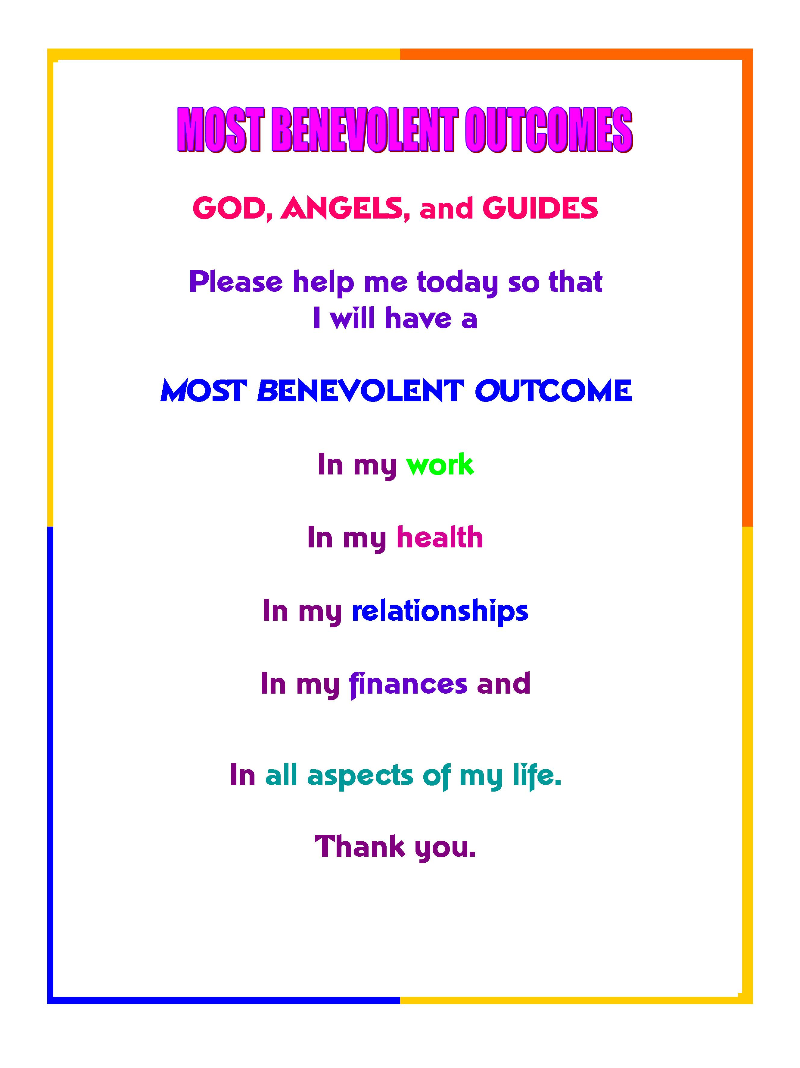
from http://oldmonkmessages.blogspot.com

* introduction *

This document was first created by Erika L Soul on April 30th 2011 with much love and devotion, from many MBO’s found in The Gentle Way newsletter & Blog by Tom T Moore and Steve Pavlina’s forum plus my own creations and rewordings and from Robert Shapiro’s Benevolent Magic . This latest edition was updated 28th March 2013.

To learn more about Most Benevolent Outcomes visit Tom’s website:
The Gentle Way and you can also receive his newsletters and subscribe to his wonderful Most Benevolent Outcomes blog by rss www.thegentlewaybook.com/blog

There will be more to come as I find new MBO’s and create them so keep in touch for new versions of this document, you can email me at soulerika@rainbowhealings.com with any great MBO stories from using any of these MBO’s and with any questions also. My website for my Healings and Reading sessions I offer is WWW.RainbowHealings.Com*

I have now created a page on facebook called Most Benevolent Outcomes and you are welcome to come read and say the MBO’s I share on the page and any resources I come across and enjoy sharing with others about MBO’s and Living Benevolent Prayers.
https://www.facebook.com/BenevolentMagic

To learn all about the practice of saying Most Benevolent Outcomes you can download or read online Robert Shapiro's *Benevolent Magic & Living Prayer*,this is the free Ebook version of his book~ http://benevolentmagic.com/pdf/benevolentmagic.pdf

Most Benevolent Outcomes tips from Robert Shapiro
This is some guidance for our readers from Robert Shapiro I received from him to help us with saying these requests. "So this is what I recommend they do first before they do a particularly meaningful Benevolent Magic or Living Prayer to them for themselves or others. I recommend they say:
"I am asking that all the most benevolent energies that are available for me be all around me and all about me now."
And then wait. If they feel an energy come up, have them wait until it fades a little bit - alright? That will be the Beings letting them know that it's alright to proceed with the next step which will be their Living Prayer or Benevolent Magic (this could also come up when saying a Benevolent Magic or Living Prayer. Have them wait if the energy comes up during saying it. That will be the Beings doing the work intensely. When it fades a bit that will be their way of letting the person know that it is alright to proceed with the words). And I recommend that they use the words exactly as they're printed either in the Benevolent Magic and Living Prayer little book or on the Benevolent Magic blog or A Mystical Man's World blog or other places like that (for example, the Explorer Race blog). That's what I recommend. by Robert Shapiro.
This is another tip for increasing the potency of your MBO’s : As I NOW say this Most Benevolent Outcome request with intent, emotion and feeling, it has the multiplying energy, force, and effect of my having stated and intended it, of nine times to the ninth power.’

* DAILY MBO'S *

★ Guardian Angel★ “ I request a Most Benevolent Outcome to be shown how this situation will likely progress in the near future with this ...... THANKYOU."
★ Guardian Angel★" I request a Most Benevolent Outcome for my life to improve in ways that are truly divinely miraculous now, thankyou"
★ Guardian Angel★ ' I request a Most Benevolent Outcome for my day Today and may I end up being a more Joyful soul than I can ever expect, imagine or anticipate. Thank you. '

★ Guardian Angel★ “ I request a Most Benevolent Outcome for my work day, and may it be even better than I can hope for or expect, thank you!”

★ Guardian Angel★ “ I request a Most Benevolent Outcome for expecting great things today, great things tomorrow and great things all this week! Thank you!"

★ Guardian Angel★ ' I request a Magical Most Benevolent Outcome for all that I am doing, being and feeling today, thankyou! '

★ Guardian Angel★ " I request a Most Benevolent Outcome that I have a safe and enjoyable drive today, and may the benefits be even more than I can ever expect or anticipate, Thankyou.”

★ Guardian Angel★ " I request the Most Benevolent Outcome to have a very joyful, blissful and love filled day that puts a smile on my face and allows me to feel absolutely wonderful and may this Outcome be even better than I could hope for or expect...thank you"

★ Guardian Angel★ " I request a Most Benevolent Outcome to meet only those people who are for my highest good, thankyou"

★ Guardian Angel★ I request a Most Benevolent Outcome for each moment of Today and for a wonderful Divine Abundantly Blessed DAY, THANKYOU“

★ Guardian Angel★ ~ I request a Most Benevolent Outcome for me to have a Most Beneficial benevolent day & evening that is for my best and highest good now, thankyou.

★ Guardian Angel★ I request a Most Benevolent Outcome for always being in the right place doing what is perfect and right for me to be doing at the right time, each and every day, thankyou ★ thankyou ★

★ Guardian Angel★ I request a Most Benevolent Outcome for making the choices each and every moment that are for my best and highest good and making choices that are the most joyful and Most Benevolent for me and all , thankyou .... ★

★ Guardian Angel★ " I request a Most Benevolent Outcome for me to experience many Magical Moments today and to welcome them and appreciate them fully, thankyou !"

★ Guardian Angel★ " I request a Most Benevolent Outcome for my whole day and for each and every moment of my day and to experience many Miracles and Blessings and to be in the Energy and Vibrational frequency of my Vortex, thankyou

★ Guardian Angel★ “I request a Most Benevolent Outcome for me to feel the soft embrace and Love of my Guardian Angel in every moment, every event, every action, and in every thought and word of this day, thank you!”

★ Guardian Angel★ " I request a Most Benevolent Outcome for doing what's in my best and highest good for the remainder of this day now, thankyou.

ི♥ྀNEGATIVE ENERGY CLEARING MBOི♥ྀ
Guardian Angelི♥ྀ I request a Most Benevolent Outcome for me and including my home, for a complete Energy Clearing of all negative thoughts and energies, negative emotions, clearing all from others not mine, clearing any lower vibrations, removing all negative entities, neutralising all disharmony, balancing all non beneficial frequencies, clearing all fear anger and judgement and transmuting all into freedom love and joy, so that I am 100% Clear and in the highest vibration of Love~ Peace~ Clarity ~Truth, fully attuned to the Highest state of Consciousness, my heart open to Love fully and enveloped in an Energy Shield Bubble of Love~ Grace~ Blessings and Light protecting me night and day continually, so that I am in Oneness and Union with the Divine embracing all with Love,♥ྀ thankyou thankyou thankyou...ི♥ྀ

* Self Love * Growth * Happiness *

★ Guardian Angel★ " I request a Most Benevolent Outcome for Feeling better ★ and staying in a positive happy mind-set, thankyou."

★ Guardian Angel★ " I request the Most Benevolent Outcome for releasing my negative emotions and being a happier healthier person, thank you"

★ Guardian Angel★ " I request the Most Benevolent Outcome for allowing myself to love myself and be loved, thank you

★ Guardian Angel★ "I request a Most Benevolent Outcome for my spiritual abilities to be increased, my intution heightened, my third-eye opened fully.. for clearer communication with my guides and angels, my spiritual awareness to increase and all in the Most Benevolent Way now, thankyou."

★ Guardian Angel★ " I request the Most Benevolent Outcome to heal and release all my fears of having good things come to me and any resistance to my good, being happy and fulfilled and may the Outcome be even better than I could hope for imagine or expect....thank you."

★ Guardian Angel★ " I request the Most Benevolent Outcome that my guardian angel help me awaken to my inner whisperings more, please help me to know and intuit the best path to take in every situation, so that my life can become a fantastic, and wonderful adventure, and may this outcome be even better than I could hope for or expect....thank you"

★ Guardian Angel★ " I request the Most Benevolent Outcome to heal and release any fears I have that may be standing in my way to having very easy and pleasant Out of my body experiences and soul travel and may this outcome be even better than I could hope for or expect...thank you"

★ Guardian Angel★ " I request a Most Benevolent Outcome for reaching higher spiritual planes through my spiritual exercises and may the results and the experience itself be even better than I can hope for imagine or expect, thank you!"

★ Guardian Angel★ " I request a Most Benevolent Outcome for having a lucid dream when I sleep and may the results and the dream itself be even better than I can hope for, imagine or expect, thank you!"

★ Guardian Angel★ " I request a Most Benevolent Outcome to reconnect with my own Guardian Angel and any other beings who wish to communicate with me, thank you!"

★ Guardian Angel★ " I request a Most Benevolent Outcome to reconnect with my own Guardian Angel and any other spiritual beings, spiritual Masters , and Angels who wish to communicate with me now, thank you!"

★ Guardian Angel★ " I request a Most Benevolent Outcome for releasing and transmuting all my Resistance to living the LIFE I truly want to Live and for now Living the Life that is most fulfilling and Most Benevolent for me and all and for me being willing to show up for IT NOW, Thank you"
★ Guardian Angel★“I request a Most Benevolent Outcome for me to find myself upon the highest path of growth and renewal, and the highest path of healing, thank you!”

*★ Guardian Angel★“ I request a Most Benevolent Outcome that all blocks that I have mentally emotionally spiritually and physically to my Ideal JOY be completely removed and replaced by pure JOY of the highest vibration for me now, thankyou !

*★ Guardian Angel★“ I request a Most Benevolent Outcome for resolving these issues and may the results be even better than I can imagine or expect, thankyou .

*★ Guardian Angel★“ I request a Most Benevolent Outcome that you work with me while I am asleep tonite, to clear away any blocks that keep me from fully enjoying my Life, following my Divine purpose, and being my true Self. Please either bring these blocks (memories) to my attention or completely remove them from my mind, body and emotions during my sleep tonite, thankyou

* HEALTH and FITNESS *
★Benevolent Prayer : I ask that my health improve and that I experience more energy, physical wellbeing and immense vitality now, wonderfully easily and effortlessly. Thankyou.

★ Guardian Angel★ I request a Most Benevolent Outcome for attaining the best weight for my health and happiness, thank you!

★ Guardian Angel★ I request a Most Benevolent Outcome for choosing the healthiest foods both at home and in restaurants, thank you!

★ Guardian Angel★ I request a Most Benevolent Outcome for being led to healthy, enjoyable exercises for me, thank you!

★ Guardian Angel★ "I now request the Most Benevolent Outcome to have a wonderful and restful sleep tonight, going to sleep easily and quickly and to wake up in the morning refreshed and rejuvenated and healed....thank you".

★ Guardian Angel★ ' I request a MBO for a quick, revitalizing nap, thankyou! '

★ Guardian Angel★ "I request a Most Benevolent Outcome for this surgery and may the results be even better than I can hope for or expect, thank you!"

And they you can say a Benevolent Prayer for the surgeon staff:
"I ask any and all beings to assist the doctors and nurses for this surgery today to operate to their highest peak of knowledge and professionalism, thank you."

★ Guardian Angel★ “I request a Most Benevolent Outcome for bringing the best care and attention to my patients today, thank you!”

“I ask any and all beings to bring healing and love to all the patients in this hospital today in the most benevolent manner possible, thank you!”

★Guardian Angel,★ I request a Most Benevolent Outcome that as I sleep tonight, I choose to easily and spontaneously release any and all limiting beliefs, whether known or unknown, that in any way block the constant and harmonious flow of my personal happiness, abundance, wealth and wellbeing, and I acknowledge that when I awake in the morning I will be in a pure and constant state of Allowing the FLOW of my personal happiness, abundance, wealth and well being , THANKYOU ★

★Guardian Angel★ " I request a Most Benevolent Outcome for Changing my Mind and Body relationship to a Most Benevolent ★ harmonious ★ loving ★ healthy exchange that creates glorious vibrant good health ★ happiness and longevity ★,
Thank you" ★

*★ Guardian Angel★“ I request a Most Benevolent Outcome for resolving these health issues and may the results be even better than I can imagine or expect, thankyou

★I am asking that any and all Beings hold a sacred healing space for this person for the highest and best good for their soul's journey." ★
★ I am asking that this person's experience in the hospital be completely benevolent for them and that their medical care and procedures and/or operation be successful and they be able to return home and/or to work as quickly and as comfortably as possible ...★
★ I ask any and all Beings to assist the medical staff to work to the best of their ability for all procedures , tests and operations, thankyou.★
★ Guardian Angel★ I request a Most Benevolent Outcome for this treatment and may I or this person Be guided to the Most Beneficial , healing Benevolent treatments for me, thankyou "★
★" I ask that any and all Beings assist this person ...in being led to treatments that will be the most healing and Most Benevolent for them now , thankyou"★

★ Guardian Angel★ I request that my health improve and that it become more easy for me to live in my body now in the Most Benevolent Way for me and that have the Most Benevolent Outcome for me , thankyou"★
★ I am asking that my health or this health issue improve now in the gentlest, most comforting and speediest way for me now !★
★ Guardian Angel★I request that _________ improve and become more gentle in my body so my health can become more Benevolent for me and that this result in the MOST BENEVOLENT OUTCOME FOR Me "★
★"I am asking that the form of Life that is generating this disease and discomfort in the people (or person) who is experiencing this , that this form of life mutate now into A benign form that will be gentle on all beings whom are being affected now ...."★
P.S. You can say this for one person with a health problem or if it is a lot of people then say it for people and being ...

* RELATIONSHIPS *

★ Guardian Angel★ “I request a Most Benevolent Outcome for the PERFECT MATE for me, thankyou!”

★ Guardian Angel★ "I request the Most Benevolent Outcome to have the perfect soulmate come to me as quickly as posssible, and maybe this outcome be even better than I could hope for or expect....thank you"

★ Guardian Angel★ " I request a Most Benevolent Outcome that all emotional cords and negative attachments to other people, that are no longer of benefit to me, be severed at this time, thank you!"

★ Guardian Angel★ “ I request a Most Benevolent Outcome for my problem with .... and may the results be even better than I can hope for or expect, thank you!”

★ Guardian Angel★ " I request a Most Benevolent Outcome for my relationship to improve with ______ and may the results be even better than I can hope for or expect, thank you!"
You can also say, "I ask any and all beings to assist ______in forgiving me so that we can be close again, thank you!"

★ Guardian Angel★ " I request a Most Benevolent Outcome for any emotional energy cords of attachment or cords not of the highest good be cut between me and this person thankyou"

★ Guardian Angel★ " I request a Most Benevolent Outcome that this relationship is wonderfully Most benevolent for me and full of Benevolent Magic , thank you!"

★ Guardian Angel★ " I request a Most Benevolent Outcome for clearing up any misunderstandings with ______ and may the results be even better than I can hope for or expect, thank you!"

★ Guardian Angel★ "I request a Most Benevolent Outcome for my relationship with .......to improve, grow and be even better than I can hope for expect or imagine , and to neutralise any and all ill effects from the past present future of this relationship upon me , my health , wellbeing, self esteem and a Most Benevolent Outcome for our whole relationship now and in the future , thankyou.

★ Guardian Angel★ "I request a Most Benevolent Outcome for attracting people who vibrate on my level or above and who can become true friends and loved ones, thankyou

★ Guardian Angel★ I request a Most Benevolent Outcome that I now notice ABUNDANCE and I welcome it into my Life in all its forms and I let go of unforgiveness in all my relationships, thankyou"
★ Guardian Angel★ " I request a MBO for all my relationships with my family to heal and improve in ways that are truly divinely miraculous now, thankyou"

* WORK and MONEY MBO’S *

★ Guardian Angel★ “ I request a Most Benevolent Outcome for my work day, and may it be even better than I can hope for or expect, thank you!”

★ Guardian Angel★ " I request a Most Benevolent Outcome for having my career progress in ways above and beyond what I could ask for or think of, thankyou"!

★ Guardian Angel★
“I request a Most Benevolent Outcome for the PERFECT JOB for me, thank you!

★ Guardian Angel★ " I request the Most Benevolent Outcome for finding the perfect dream job for me, and may this outcome be even better than I could hope for or expect....thank you"

And then each job interview you say,
★ Guardian Angel★ “I request a Most Benevolent Outcome for the results of this interview to be even better than I can hope for or expect, thank you!”

★ Guardian Angel★ "I request a Most Benevolent Outcome to help me increase the flow of Abundance and Prosperity in my life, thankyou"

★ Guardian Angel★ "I request a Most Benevolent Outcome to help me increase my intuitive awareness so that I can better "hear" and 'follow" any little whispers & nudges from my GA so that I can navigate my way through my financial and work situation, resulting in many Most Benevolent Outcomes and a Most Benevolent Income, thankyou!

★ Guardian Angel★ I request a Most Benevolent Outcome for very creative ideas to flow to me to help me pay all my bill's and all my living expenses in ways I have never thought of, thankyou" and “I request a Most Benevolent Outcome for obtaining more money than I will need for the rest of my life, thank you.” Thankyou, thankyou, thankyou

★ Guardian Angel★ I request a Most Benevolent Outcome for obtaining more Money than I will need for the rest of my life, thank you.”

★ Guardian Angel★ I request the most benevolent outcome to get some help with my payment for my .......bill and may this outcome be even better than I could hope for or expect....thank you".

★ Guardian Angel★ I request a Most Benevolent Outcome for the PERFECT job for me now, and may the results be even better than I can hope for or expect, thank you!”

★ Guardian Angel★ I request a Most Benevolent Outcome to have my credit card bill be fully paid off in some miraculous way now, and a zero balance , thankyou thankyou thankyou"

★ Guardian Angel★ I request a Most Benevolent Outcome that I be fully open to all possibilities that lead me to the highest and most Divine expression of my soul, and all of the experiences my beautiful soul chooses this lifetime. Thank you, thank you, thankyou!

★ Guardian Angel★ I request a Most Benevolent Outcome that New Channels of Wealth Open to Me Daily now, THANKYOU“

★ Guardian Angel★ I request a Most Benevolent Outcome for New Fields of Divine Activity to Now Open Up for Me !! THANKYOU”

★ Guardian Angel★ I request a Most Benevolent Outcome that As I sleep tonight, I choose to easily and spontaneously release any and all limiting beliefs, whether known or unknown, that in any way block the constant and harmonious flow of my personal happiness, abundance, wealth and wellbeing, and I acknowledge that when I awake in the morning I will be in a pure and constant state of allowing the flow of my personal happiness, abundance, wealth and well being , THANKYOU (From Linda Miller)

★ Guardian Angel★ I request a Most Benevolent Outcome that I now notice ABUNDANCE and I welcome it into my Life in all its forms and I let go of unforgiveness in all my relationships, thankyou"

★ Guardian Angel★ I request a Most Benevolent Outcome that I now notice ABUNDANCE and I welcome ABUNDANCE into my Life in all its forms and I experience true forgiveness in all my relationships, thankyou "

★ Guardian Angel★ “I request a Most Benevolent Outcome that my personal established identity in all of its forms be safe & secure from harm and corruption by others at all times. Thank You”

“★ Guardian Angel★ “I request a Most Benevolent Outcome that my computer hard drive & all my programs remain safe & secure from harm and corruption by others or any cause. Thank You.”

★ Guardian Angel★ "I request a Most Benevolent Outcome to Resolve & Dissolve the cause of all the blockages ,limiting beliefs, memories that I have that are preventing me from experiencing the happiness my partner feels from having a job that he truly enjoys and is successful in and earning a great income and may the results exceed all my expectations, THANK YOU!"

★ Guardian Angel★ "I request a Most Benevolent Outcome to resolve the cause of all the blockages and/or limiting beliefs that are preventing me from witnessing myself losing all extra fat and weight I have as I am also taking delight in preparing healthy meals that looks and taste delicious, and may the results exceed all my expectations, hopes and desires, Please and THANK YOU!"

"I ask any and all Beings to assist myself and my family to become more prosperous and abundant in ways that are perfect and right for them and what they desire resulting in many Most Benevolent Outcomes may Thy Will be Done, thank you..

"I ask any and all beings for a Most Benevolent Outcome to assist in leading my relatives to new ways to earn money in ways that are perfect and right for them and what they desire resulting in many Most Benevolent Outcomes, may Thy Will be Done, thank you"
★ Guardian Angel★ "I ask any and All Being for a Most Benevolent Outcome for my relatives to find other sources of income, as they desire, thank you!"

★ Guardian Angel★ "I request a Most Benevolent Outcome to allow myself to be helped, to allow magic and miracles to happen for me, to allow myself to free of all my blockages and to be ready prepared for all my good to manifest now that is for my best and highest good, all resulting in magical Most Benevolent outcomes." Thankyou
★ Guardian Angel★ "I request a Most Benevolent Outcome to Resolve & Dissolve the root cause of all the blockages, limiting beliefs, and memories I have that are preventing me from experiencing the happiness I feel from having a job that I truly enjoy and I am successful in, earning a great Most Benevolent Income and may the results exceed all my expectations, THANK YOU!"

★ Guardian Angel★ "I request a Most Benevolent Outcome that I now exceed all my Expectations for me and my Life , thankyou”

★ Guardian Angel★ “I request a Most Benevolent Outcome for always expecting great things from now on in my work and income each day and every week and a Most Benevolent Income! Thank you!"

★ Guardian Angel★ “I request a Most Benevolent Outcome for my being OPEN to receiving Money from anywhere, for Releasing all limiting beliefs about how Money can come to me, for CHOOSING to know and believe that Money can come to me from anywhere, for realising I DESERVE to receive Money from anywhere, that Money comes to me now in Miraculous and Unexpected ways and for my being GRATEFUL for the Money that comes to me in large amounts from anywhere, thankyou “

★ Guardian Angel★ “I request a Most Benevolent Outcome to receive messages, guidance for my mission and to make a difference in my career, thankyou

★ Guardian Angel★ I request a Most Benevolent Outcome that I let Go of All Resistance with respect to my career, work and income now and that people who are searching for exactly what I have to offer are drawn to me naturally and divinely and this sharing elevates us both now , thankyou ...

★ Guardian Angel★ I request a Most Benevolent Outcome for my having wonderful work that allows me to feel happy and fulfilled as much as possible and provides Benevolent nurturing income for me as well and that this occur in the Most Benevolent way for me and that this have the most Benevolent Outcome for me , thankyou ..

★ Guardian Angel★ I request a Most Benevolent Outcome for any and all beings to assist me to become more prosperous and abundant in ways that are perfect and right for me now and what I desire resulting in many Most Benevolent Outcomes, thank you..

★ Guardian Angel★ I request a Most Benevolent Outcome to assist in leading me to new ways to earn money in ways that are perfect and right for me and what I desire resulting in many Most Benevolent Outcomes, thank you"
★ Guardian Angel★ "I request a Most Benevolent Outcome for me to find other sources of income, perfect and right for me now, resulting in a Most Benevolent Income stream thank you!"

★Guardian Angel ★ I request a Most Benevolent Outcome for a wonderful amount of cash to come to me now in a happy way, thankyou !
ི♥ྀWith the Divine, I now create a Most Benevolent Outcome in my finances, increasing my personal income in the most wonderful ways that blesses me, my family and my life, resulting in the Most Benevolent Outcome for my financial future creating financial wealth and Prosperity, thankyou .. ི♥ྀ

MISCELLANEOUS MBO'S
GUARDIAN ANGEL ,“I request a Most Benevolent Outcome that my computer hard drive & all my programs, everything with my computer my email program , my email addresses and all my online websites, blogs and social media networks and websites I am on remain safe & secure from harm and corruption by others or any cause. Thank You.”

♥ Benevolent Prayer ♥ ღ¸☆´¯`•.¸¸. ི♥ྀ.:~.••.¸ღ¸☆ ANGELS~ We ask that we become closer to you now, listening and hearing your voice and guidance in our lives, we ask that we tune into you more often and become more aware of your divine presence, we ask that you come to us in our dreams and share your love and wisdom in ways we can recognise and remember when we awaken , we thankyou Angels and we Love you, God Bless . ღ¸☆´¯`•.¸¸. ི♥ྀ.:~.••.¸ღ¸☆

~CLEARING SPACE ~MOST BENEVOLENT OUTCOME !
~.••.¸ღ¸☆´¯`•.¸¸. ི♥ྀ.: ~.••.¸ღ¸☆´¯`•.¸¸. ི♥ྀ.:~.••.¸ღ¸☆
I ask any and all beings to assist me with organising, clearing, cleaning, decluttering my home, my mind, my energy and my being and for feeling and being organised in all my spaces, all my rooms, my cupboards and robes, my home, my paperwork, my computer, my car, my workspace, my garage, my garden, and for my being open to receive the energy and whatever is needed for this shift so that I am in perfect and divine Order within and without including my home and life too thankyou, this all resulting in many many Most Benevolent Outcomes and Benevolent Magic, thank you, thank you, thank you AND IT IS DONE♥
~.••.¸ღ¸☆´¯`•.¸¸. ི♥ྀ.: ~.••.¸ღ¸☆´¯`•.¸¸. ི♥ྀ.:~.••.¸ღ¸☆

BENEVOLENT PRAYER :
I ask that Divine Love now dissolves and dissipates every wrong condition in my mind, body and affairs ~ with the result of ALL being in perfect and Divine order and HARMONY in ALL areas of my life and on ALL levels of my being NOW , thankyou ..

ི♥BRAIN BALANCE HEALING MBO ♥ྀ:
.ི♥ྀGuardian Angel, I request a Most Benevolent Outcome for a total Brain Balance Healing for my physical and etheric brain to be in total balance and harmony, for 100% overall brain health and functioning, for all on this list to be done that is for my best and highest good right now and continue to keep my brain in this balanced harmonious state for the next 24 hours for and/or for as long as possible now, thankyou.
*Balance my Brain totally ,
*Hydrate the cells in my brain fully
*Oxygenate the cells in my Brain fully
*Balance the Blood flow to my brain 100%,
*Balance all Brain chemicals levels,
*Balance my hormones, *Make All electrical activity in my brain in perfect harmony and flow,
*Balance my Blood sugar levels in my body and brain,
*Put my brain on its ideal brain wave frequencies & maintain it at the best brainwave frequencies for me in each moment over the next 24 hours and longer ,
*Balance both my Brain hemispheres,
*Whole brain integrated,
*Improve my Brain functioning to 100%,
*Neutralise All ill effects of trauma and stress from any negative thought or emotion or experience on my Brain,
*Heal any and all Negative charges on all negative thoughts emotions memories in each cell in my physical and etheric brain.
*Neutralise any and all Negative thoughts in my conscious and subconscious mind ,
*Heal ALL stress and trauma in every cell of my physical and etheric brain,
*Create a calm clear happy bright positive Brain,
*Improve my recall, memory and organisational abilities,
*Reboot, repattern my brain and keep it clear and balanced. * Neutralise any and all ill effects of EMR on my brain and any harmful influence of EMR and electronic devices
*My mind and my brain now in perfect and divine order
*Level of love in my brain at optimum levels
*Integrated Brain Activation
.ི♥ྀ

Guardian Angel,
I request a Most Benevolent Outcome for this MBO collection;
that the people who would greatly benefit from having this document come across this or receive it from someone, that all of these Most Benevolent Outcomes here serve all in creating Many Most Benevolent Outcomes and wonderful experiences and serve their souls development , that I share this in wonderful and divine ways with others as I am guided to in great online places and in print form also and that I find great new MBO’s to add easily to this and create this doc in great formats fonts and divinely designed for ease of sharing, and may the results be better than I could hope for, expect or imagine, thankyou.

May the Blessings Be
Erika L Soul
Angel Channelling Guide
Spiritual Counsellor
Soul Energy Healer

Transformational Healing Readings
Melbourne, Australia
WWW.RainbowHealings.Com*

Most Benevolent Images:


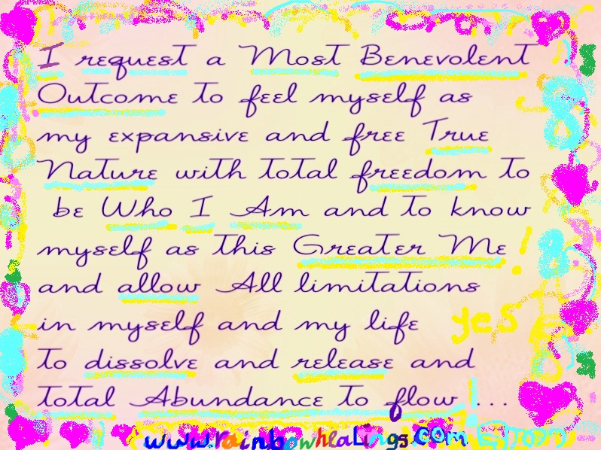

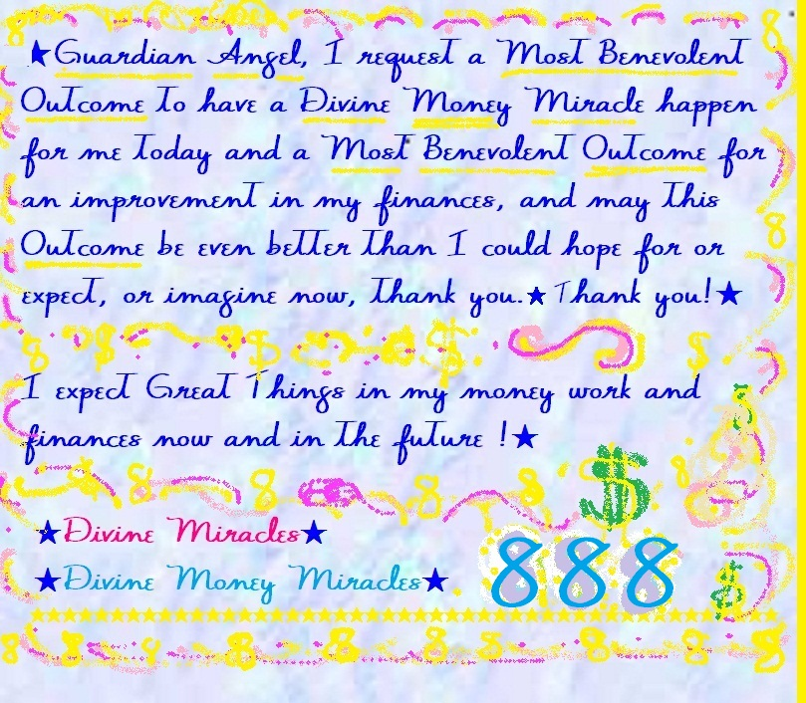

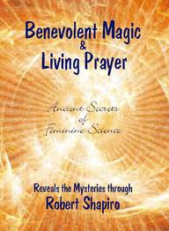
Click image for link that takes you to this free ebook

