:★: DOWSING MONEY ALLERGY Protocol :★:
You can dowse and reinforce this protocol for yourself by stating this protocol outloud with intent and feeling and or dowsing it with a pendulum and this will increase the effectiveness of this for yourself. If you know how to dowse or muscle test or intuit, you can ask the question "To what degree do I have a money allergy,?" out of 100% and then dowse again at the end of the 21 Days to see how much it changes. And you can ask "how much will my dowsing this 21 Days Money Allergy Dowsing benefit me and my life and family?
:★: Dowsing this for yourself : ★:
All those who can dowse this with a pendulum for themselves can see where they are on this chart I have created by asking what money energy frequency they are vibrating at right now. Either use a dowsing chart using 1-9 on the left and right side or use this chart below. Then dowse the whole money allergy protocol and next recheck the chart to see the new frequency you are vibrating to. If you don't know how to swing a pendulum then simply state the whole protocol with energy outloud and you can use muscle testing or your intuition to see what your new percentage is..
Removing a Money Allergy and installing Money Prosperity & Abundance.
★ I remove from my own, my mother’s, my father’s and their lineages ( all past generations) including all I took on from anyone anytime anywhere, all inherited original causes, core beliefs and effects related to money allergies including making and having money, receiving money, all fear connected to money, all trauma relating to money, all resistance to money and rejection of money, all feelings of being unworthy and any underlying trapped emotion of shame & any other trapped emotions, all distractor implants controlling me with money, all blocking money flows on any level, and I do so throughout all time space and dimensional matrices both known or unknown. I love you. I am sorry. Please forgive me. Thankyou. I declare it is so. And It is done. So be it. Thank you ★
[Stop spinning the pendulum and let it come to rest which is neutral or stop spinning your finger]
Now fill the void you have created with positive energy by spinning the pendulum or your finger clockwise and state :
★ I now translate, transmute, transform, transfigure, release and repair all that I have removed from my field and I now fill this void with 6th dimensional energies or higher of Love, Light & Sound, and the feeling of Self-worth, Prosperity, total Allowance of my being financially wealthy and abundant, so I can accomplish my soul path in this lifetime and benefit all. I love you. I am sorry. Please forgive me. Thankyou, I declare it is so. And It is done. So be IT. Thank you ★
[Stop spinning the pendulum and let it come to rest which is neutral or stop spinning your finger]. Clear for 21 days to install new programming.
*******************************************************************************
:★: Extra Bonus Dowsing for our best and highest Good :★:
We now dowse each persons frequency Range to that of the highest percentage of this chart here of Faith in an All Suffiency of Supply so that each person comes to the highest level most benevolent for them right now, adjusting their frequency now to bring about total Faith in all Suffiency of Supply of all that is required for each persons Prosperity and Financial Wellbeing, thankyou God.
*****************************************************************************
★PLEASE NOTE ★ This is my own version of Tyhson Banighen's Money Allergy protocol, I have added and changed some of the wording, Tyhson Banighen’s website is www.energydetective.ca
If you would love to give a ThankYou Gift of a monetary donation you can do this via my website shopcart using either Paypal or Credit card via this link: www.rnbwh.com/agreeddonation or via my www.paypal.me/soulerika page.
Anything you give will be received as a Divine gift and Blessing and will help support me SoulErika in continuing to facilitate this healing work, Thankyou.
★ Erika L Soul
★ Energy Dowser
★ www.rainbowhealings.com
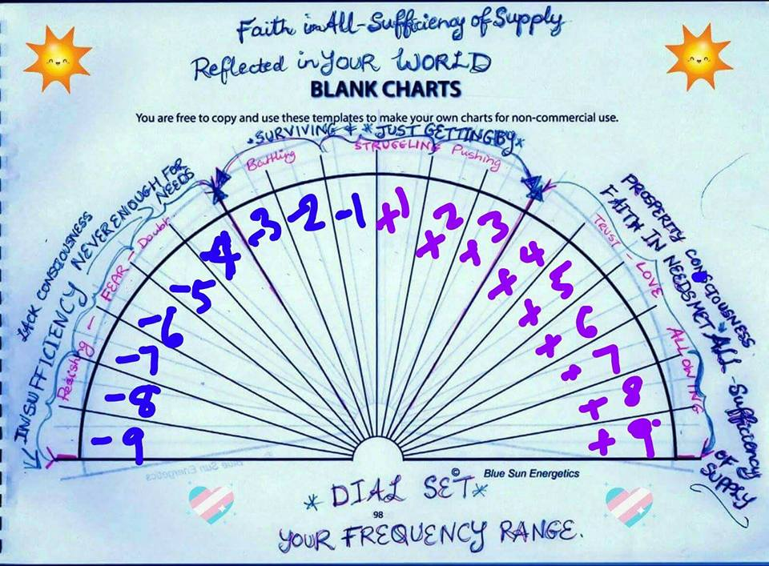

Original version

Removing a money allergy and installing money prosperity and abundance

I remove from my own, my mother’s, my father’s and their lineages ( All generations ) all inherited original causes, core beliefs and effects related to money allergies including making and having money and all feelings of being unworthy and the underlying trapped emotion of shame and any and all underlying trapped emotions, and I do so throughout all time space and dimensional matrices both known or unknown. I love you. I am sorry. Please forgive me. I declare it is so. It is done. So be it. Thank you.

[Stop spinning the pendulum and let it come to rest which is neutral or stop spinning your finger]
Now fill the void you have created with positive energy by spinning the pendulum or your finger clockwise and state :

I now translate, transmute, transform, transfigure, release and repair all that I have removed from my field and I now fill this void with 6th dimensional energies or higher of love, light and tone and the feeling of self-worth, pride in being wealthy and abundant so I can accomplish my soul path in this lifetime. I love you. I am sorry. Please forgive me. I declare it is so. It is done. So be it. Thank you.
[Stop spinning the pendulum and let it come to rest which is neutral or stop spinning your finger].
Clear for 21 days to install new programming.

