THE BARB BALL

First of all, I will bring you up to date in the life of Alyssa Mary Rose. I have withdrawn from doing any public healing. There are ways to heal that are at this stage easier to do without any attention on me. I have certainly not stopped healing but am now doing healing through more etheric means and the power tool of choice is Abundance of Light Cord cutting. This is such a powerful tool that it can be used to Enlightenment and beyond.
As to worldly matters my life is healed, I no longer worry about my children, I know they are children of Light and do not need me to worry about them. I have my dear twin flame with me and have been with him for many years now. Without him I would have found myself in a much lonelier position. We work so well together and he is such an immense support, that I do believe without him I could not being doing the work I am today.
Back in 2003 when the technique of cord cutting was channelled through me, I started what I called my Angel lady group. One of the members was called Barb. A number of months ago Barb passed over. On the day of her passing I and another couple of psychics did some cord cutting for her to ease her into her newly found state. It matters not how spiritual you are, most people when they pass over still have things that they wished they had done differently or they are upset by how sad others are about their passing. Cord cutting works even more powerfully when somebody has passed beyond the Veil. When we pass over, many things become clear as to the nature of the human world and the spirit world and most times we become much more accepting of healing on offer. This healing is actually available all the time but needs us to consciously accept it. One of the psychics I was working with has an incredibly powerful third eye so I was the cutting power house (as the rule is, whatever you have cut for yourself you can cut for another, there is very little left that I have not cut for myself) and Barb was the powerhouse on the other side of the veil. Barb being an angel lady gets the whole cord cutting thing so she was massively instrumental in the creation of the Barb ball, hence it was named in her honour.
Some of the cord cutting we did, involved cutting for all women abused in war. One of the visions that came with that one was the women arising healed and then passing on the healing to the soldiers who came to kneel at their feet. Another cut was for all the beings who perceived themselves to be stuck in hell. Some were dragged out looking like blobs, then turning into beings that looked like Greys (alien forms) and at this point we cut for them having to identify with a particular race of being. At that point they seemed to transform into iridescent dragonflies, with some of them joining the Barb ball to help others and others flying off to other worlds. There were many deep cuts made. They were not reserved to this world they were for all beings and all hierarchy involved in the spirit world related to their particular worlds, to the effect that all realised that we are one and all started to help in their own way, to lend their love and knowledge to the Barb ball. Through the work we all did together the Barb ball is self-sustaining, and people and all beings can access it when they pass over but also while in body, through their dreams and during meditation. Another little tweak is that when somebody puts something in the rubbish bin or recycle bin, we have asked that the barb ball surrounds that bin and takes any unwanted emotions also and transmutes it to love.
If you think about it every soul on earth throws away rubbish and if we could throw out our negative thoughts and emotions as often as we throw away rubbish, we might have much less clutter in our minds.
The healing that this can bring should not be underestimated. The days of using karma as a method of growth and eventual healing are numbered. The Barb ball used the LAW OF GRACE. Let me give you an example, somebody commits suicide, then on the other side they see how upset everybody is, so this usually means to balance their karma they stay around spirit side trying to get through their apologies to those left behind. They could also have to go back, into another rubbish life and resist the urge to kill themselves this time.
With the Barb ball you can just step in and relieve yourself of all that irksome karma and move onto something you really want to do. This also works for mass murderers, with the laws of karma you might be working on this for lifetimes but with the laws of Grace you could actually turn things around to the point you can come back and help others who think it is ok to maim and murder. If we could transmute all this negative karma that we all accumulate as easily as having a shower, we could all realise that we are LOVE and as one much more quickly. As each person or being adds their love to this system it is becoming more and more pervasive and more available to all beings. All you need to do to access this wonderful gift of alchemy is to ask for the healing gift of love enveloped in a ball of light we have named the Barb ball.
Today my dear friend Erika L Soul got in contact with me after many years and sent me her post about the beautiful Golden Bliss Ball. Seems she knew of its existence before it actually existed. Or maybe there is no time and it has existed across all time, however once a thing is named its’ power grows exponentially, so we can now all benefit from healing in the form of a Barb or Golden Bliss ball.
Thankyou Alyssa Mary Rose

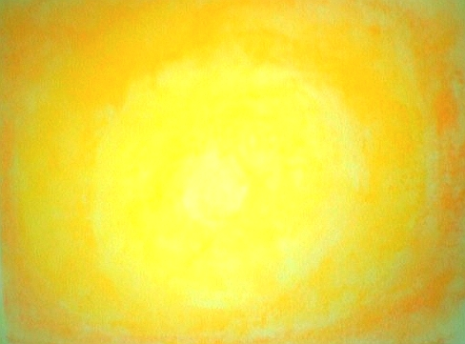
Erika L Soul ~ Intuitive Healing Art

Divine Golden Bliss Balls of Love
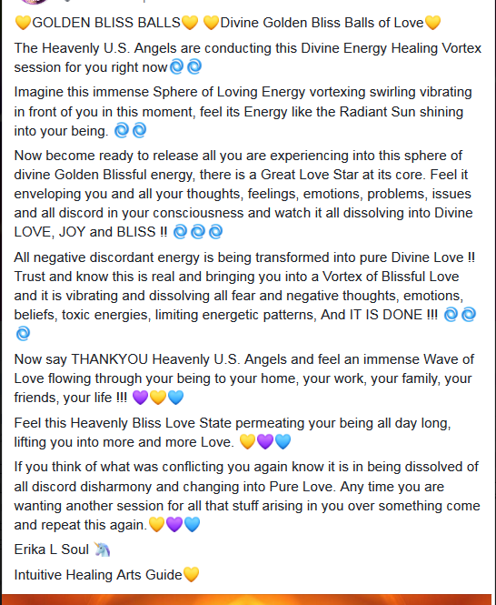

Erika L Soul
Intuitive Healing Arts Practitioner
www.rainbowhealings.com

